Inspirational History for the UN Community

Outer environment and inner support for prayer, meditation and reflection

with contribution by Sri Chinmoy: the Peace Meditation at the United Nations.

Remember the Past to Inspire the Future

"If we say that the United Nations is the result of the twentieth century awakening, then we are mistaken. The United Nations is the outgrowth of the inner awakening of human beings from time immemorial." (/rd-8)

Let us be grateful for the deeply connected histories of the United Nations, founded in 1945, and the Peace Meditation Group, which came into being 25 years later. Let us appreciate the multi-generational efforts that have resulted in real progress since then.
The world made a brave attempt at international progress towards peace through the League of Nations, which Sri Chinmoy deeply appreciated. The vision of the League was later carried forward and expanded by the United Nations Charter and the Universal Declaration of Human Rights  It is now also expressed in more detail through the Sustainable Development Goals (SDGs)*.  Full text of the Goals is available at : https://www.un.org/sustainabledevelopment | 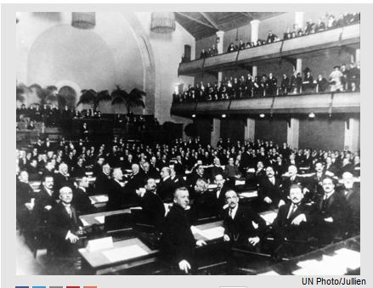  League-of-Nations-at-opening-session-Geneva-1920-nov-15-un-photo-julian-97289.jpg 41 KB 41kb[/caption]
/*End Note: The Sustainable Development Goals (SDGs) are 17 interconnected Goals which the nations of the world have agreed to target for achievement by 2030. They represent a call for action by all countries to promote prosperity while protecting the planet. They recognize that ending poverty must go hand-in-hand with strategies that build economic growth and address a range of social needs including education, health, social protection, and job opportunities, while tackling climate change and environmental protection. More at : https://www.un.org/sustainabledevelopment/
The world is making observable outer Progress
Inner reflection supported since UN’s Beginning.
Silence opens and closes Annual UN General Assembly Sessions | 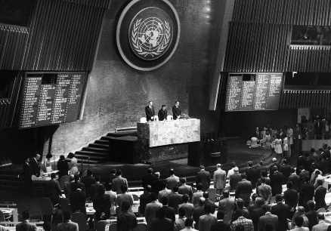  un-photo-247181-open-ga-minute-silence-1975-Teddy-Chen-crp.jpg 1mb
Since the earliest days, the UN General Assembly sessions have opened and closed with an invitation to all delegates to observe one minute of silence dedicated to prayer or meditation* (UN Photo #247181/Teddy-Chen).
*Rule 62 of the Rules of Procedure of the General Assembly provides that: “Immediately after the opening of the first plenary meeting and immediately preceding the dosing of the final plenary meeting of each session of the General Assembly, the President shall invite the representatives to observe one minute of silence dedicated to prayer or meditation.”

.

The first and second UN Secretaries-General, Trygve Lie and Dag Hammarskjöld, established and redesigned the Meditation Room – “A Room of Quiet” located adjacent to the General Assembly public lobby.
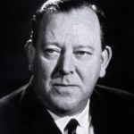  UN-photo-54480-Trygve-Lie-Norway-1st-UN-SG-Feb-1946-Apr-1953-crop.jpg 1 MB | 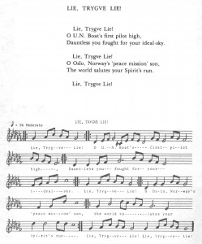  bu-scpmaun-1977-02-27-vol-05-n-02-feb_Page_43-song-sg-trygve-lie.jpg 512 KB | 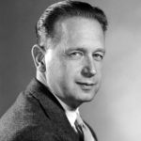  UN-Photo-60981-Dag-Hammarskjöld-Sweden2nd-UN-SG-10-Apr-1953-18-Sep-1961-2mb-crp.j | 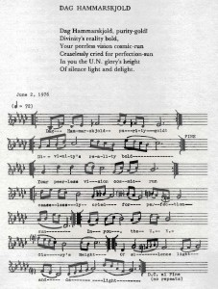 bu-scpmaun-1977-07-27-vol-05-n-07-jul_Page_42-song-dag-hammarskjold.jpg 796kb
(also note point to song words 2 SG Song of the Soul booklet?)

"]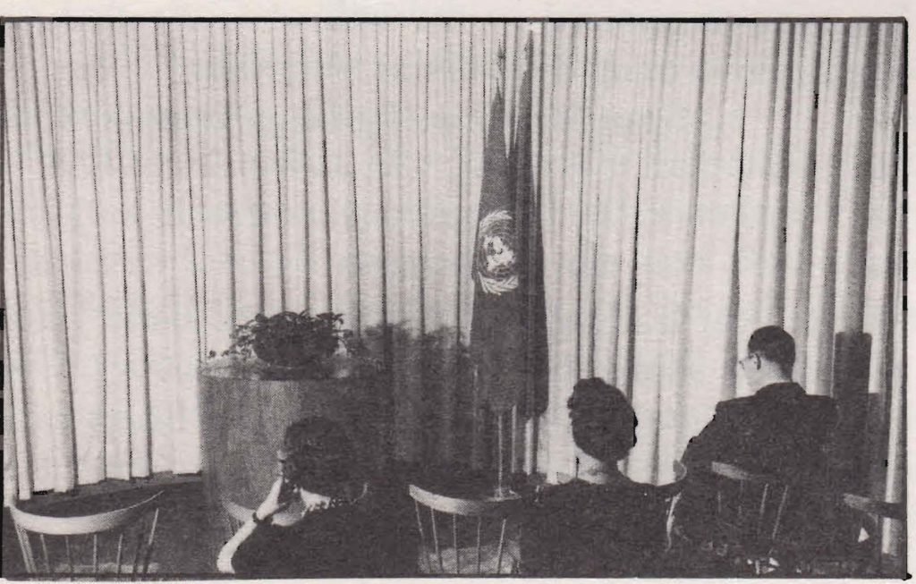
A view of the original Meditation Room at the 1940’s United Nations Headquarters in Lake Success, New York. pmaun-rpt-1977_Page_19-photo-orig-med-rm-top-no-label.jpg 540 KB

1968 Excerpts from Sri Chinmoy's first talk to UN Community:
In November of 1968, Sri Chinmoy was invited to give a talk to the UN Community in New York. "The Song Universal" shared the necessity of feeling the entire world as one’s real home. The importance of peace, oneness and deep appreciation of various religious faiths was also expressed. A few excerpts of the talk follow:
The Song Universal
"The Song Universal is freedom. Freedom from what? Freedom from limitations, freedom from imperfections and freedom from ignorance.
"Freedom does not mean being away from home. Freedom means accepting and feeling the entire world as one's real home, as one's very own.
"Our inner realisation and outer action must run abreast. Outer achievements should be the conscious and spontaneous revelation of the inner divinity.
"Love, harmony, peace and oneness. ... On the strength of his inner mounting flame, aspiration, man can easily, unerringly and spontaneously manifest these ideals...in every sphere of life.
It is quite natural and proper that we should discover our God in and through our own religion. When we go deep within we come to realise that there is only one religion, and that religion is man's inmost cry for God-Realisation.

- Sri Chinmoy at the Church Center for the United Nations, November 26, 1968. Printed in The Garland of Nation-Souls, Agni Press, 1972 , Full talk at https://www.srichinmoylibrary.com/gns-4

April 1970, Begin ongoing Peace Meditations led by Sri Chinmoy at the UN.
In 1970, the third UN Secretary-General, U Thant invited spiritual leader Sri Chinmoy to offer regular meditations for staff and delegates at UN Headquarters.  Inauguration Meditation April 1970 (excerpt)  “Today's United Nations was yesterday's perfecting Vision. Tomorrow's United Nations is today's fulfilling Realisation.  “Unity is not oneness. A bud is not a flower.  “The presence of unity is the immediate end of human imperfection and limitation. The presence of oneness is the glorious beginning of man's perfect Perfection.  - Sri Chinmoy, 14 April 1970, Printed in The Garland of Nation-Souls, Agni Press, 1972, srichinmoylibrary.com/gns-27 | 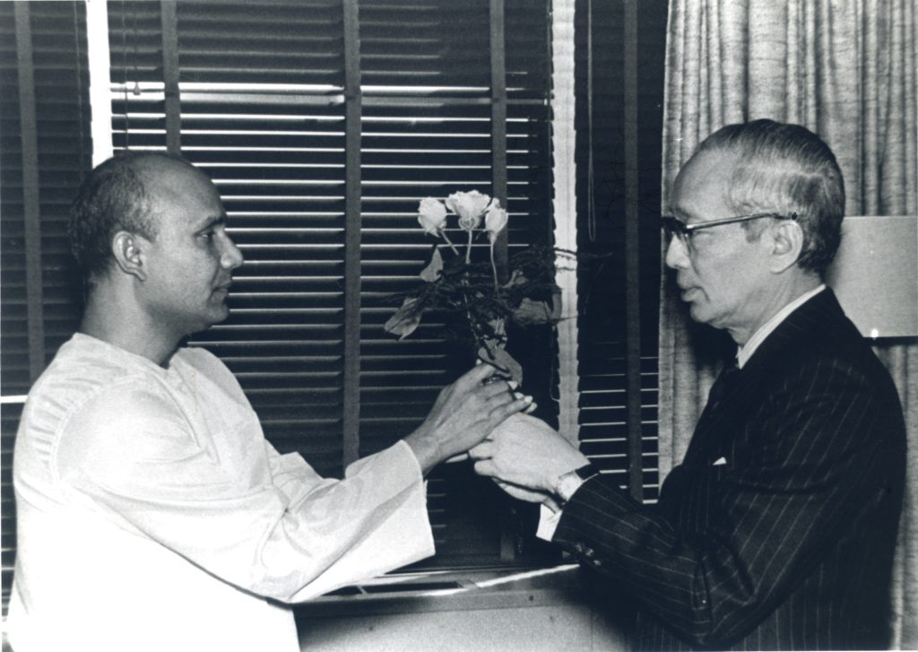  ny235-1972-02-29-Sri-Chinmoy-with-SG-UThant.jpg (24 MB)
ED Note: See also alternate Photos for U Thant at end -below

This began decades of contemplative events and programmes by Sri Chinmoy and the meditation group at the UN. Some highlights, excerpts and photos are included in this booklet

Dag Hammarskjold Remembered
29 Jul 1977, On the birthday of Secretary-General Dag Hammarskjold, Peace Meditation Group members joined Sri Chinmoy to observe a few minutes of silence in the small but symbolic meditation “Room of Quiet”, re-designed by Dag Hammarskjold in 1957.
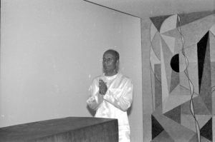  1977-07-29-04-ckg-room-of-quiet-med-room-honor-day-ham.BIG | The Group then held a programme in the UN Dag Hammarskjold Library Auditorium which included meditation, a talk, instrumental and vocal arrangements of a song by Sri Chinmoy dedicated to Dag Hammarskjold, a choral reading of Hammarskjold’s writings, and tributes.
Early Friends of the Meditation Room Honored  On 10 August 1977, at the Wainwright House in Rye, New York, speakers from the UN and the Wainwright House honoured Weyman C. Huckabee, the Laymen’s Movement Executive Director from 1941 to 1969, for his part in the encouraging a Meditation Room at the UN and the UN to open and close its General Assembly Meetings by observing a moment of silence.  The programme opened with silent meditation, followed by musical selections played by Sri Chinmoy on the Indian esrai.  The involvement of the Friends of the Meditation Room and the Laymen ‘s Movement in early years to establish the Meditation Room at UN in New York were honored. Members of the Meditation Group at UN were invited as special guests. |  | 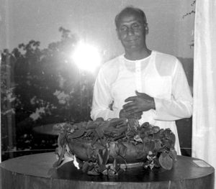  Sri Chinmoy with furnishings from 1940s Original Meditation Room at Headquarters in Lake Success NY, preserved at Wainwright House, Rye NY.  1977-08-10-14-sri-chinmoy-in-room-orig-un-med-furrnishing-alter-small-plaque-right-scaled.jpg

Robert Muller, UN, Deputy Under-Secretary-General :
“When I learned that the old Meditation Room from Lake Success was here in Rye, I tried to remember as many details as possible of the first premises of the United Nations on Long Island. I found that I was unable to remember the hall of the General Assembly, the Security Council and even my own office . But when it came to the Meditation Room, I remembered many details. I could see clearly the large tropical tree trunk from Africa, the bowl of flowers or greenery on top of it and the semicircular rows of chairs for the visitors.
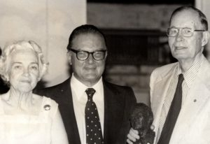  1977-08-10aug-rye-ny-med-room-un-r-mwller-mr-mrs-huckabbe-holding-small-bust-crp-scaled | “Tonight, after thirty years, I saw it again and I was struck by the accuracy with which it had remained engraved in my memory. I am therefore tempted to believe that despite all the attractions of material life and the fascination of new knowledge, spirituality and its symbols go much deeper and leave an extraordinary, indelible mark in us. Yes, I lived a very rare moment tonight, rediscovering emotions and images which were a third of a century old."
Mr . Weyman Huckabee, Laymen’s Movement Executive Director from 1941 to 1969:
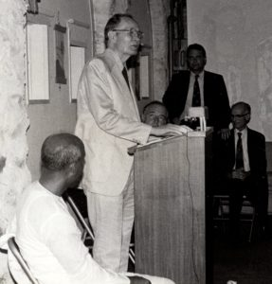  1977-08-10aug-rye-ny-med-room-un-Weyman-C-Huckabee-Laymen's-Movement-Executive-Dir-1941-1969 speaks | "one experience ... has to do with my meeting Pope Pius the XII when I was given a private audience to talk with him about the Meditation Room in the United Nations and about the day of prayer set aside for prayer and meditation for world peace. He received me warmly.  “ I asked why there was still so much violence in the world in spite of the efforts made to bring peace. He said , 'That is a very difficult question.' Then, after a pause he continued , “Because , even though we know the Truth, we do not abide by it. I am very happy to be here. ... I am grateful for your love, for your concern and for your friendship." For more on Wainwright event see Periodic Bulletin "Meditation at the United Nations" August 1977
ED NOTE: For more info while finalizing this page, also see links below "Considered but not used" section:
20th Anniversary of the redesign of the Meditation “Room of Quiet”
On 15 November 1977, a programme sponsored by the Peace Meditation Group marks the 20th Anniversary of the redesign of the Meditation “Room of Quiet” adjacent to the UN General Assembly Lobby,  This space was redesigned by Dag Hammarskjöld in 1957.  First, A few minutes of silence was observed in the small but symbolic Meditation “Room of Quiet”  The formal programme took place in Conference Room 4. | 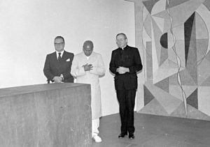  (Shown left to right, Robert Muller, UN Deputy Under-Secretary-General; Sri Chinmoy, leader of the Peace Meditation Group; and Monsignor G. Cheli, Permanent Observer of the Holy See to the UN). 1977-11-15-06. room of Quiet redesign anniversary R-Muller-Sri-Chinmoy- G-Cheli-silence-13 MB
Speakers at the observance in Conference Room 4 included: Mr. Robert Muller; Msgr. G. Cheli; Mr. C. P. Romulo, Secretary of Foreign Affairs of the Philippines, (and an original signer of the UN Charter); Judith Hollister, Representative of Wainwright House (where the furnishings from the first meditation room at the UN’s early Headquarters at Lake Success, were displayed in 1977).
Statements were provided by: Mr. Andrew Young, Permanent Representative of the United States to the United Nations. Cardinal T. Cooke, Archbishop of New York; Mr. Peter Stewart, of the Thanks-Giving Foundation in Dallas, USA (which was responsible for the 1985 gift to the UN from the USA, of Norman Rockwell’s famous mosaic, ‘The Golden Rule.’)
The Meditation Group Choir performed songs composed by Sri Chinmoy, which included words of several UN Secretaries-General set to music.

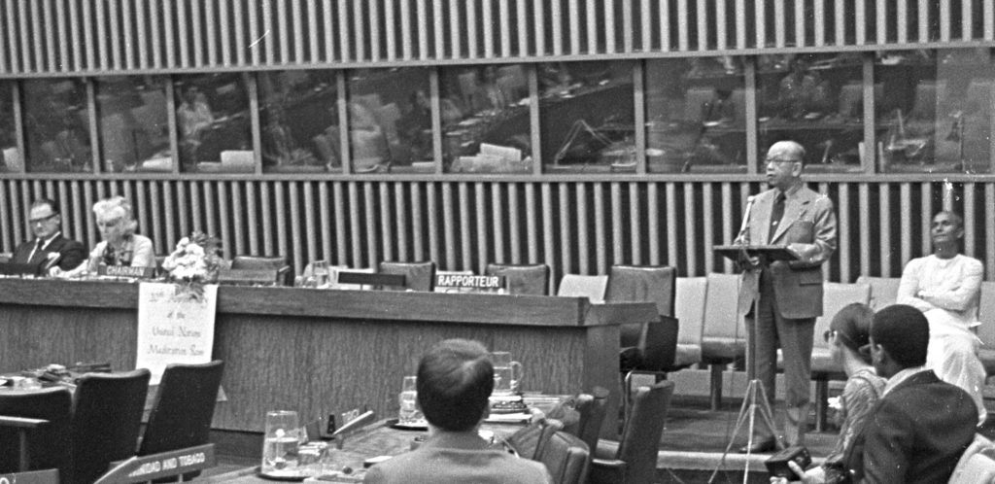

1977-11-15-02-1-Room-of-quiet-anniversary-Romulo-phillipines-speaks-crp-scaled 582kb -see to crop (1977-11-15-02-1.jpg romulo-speak-crop-with-panel (13 MB)
Excerpts from event (Ed note: might not need full title if used above):
Monsignor Giovanni Cheli, Permanent Observer of the Holy See
"Silence is like a friend. It must be cultivated . If we wish meditation to flourish within us, we need to help it to grow. We can do that only by setting aside times in our day when we can pay attention to the quiet within us so that we renew our awareness of its beauty and its grandeur."
H.E. Dr. Carlos P. Romulo, Secretary of Foreign Affairs of the Philippines (and an original signer of the UN Charter in San Francisco)
"The United Nations is a centre for harmonizing action, as the Charter continually reminds us. But the process of harmonizing is a difficult one. All too often passion and conflict rule the day. It is at such moments that we need the Meditation Room to look in to ourselves and to encounter our God, so that we may cleanse our spirit and gain needed strength. This I have done many times."
"Thousands have visited the Meditation Room and no doubt thousands of others will do so in the future . They will sit there in silent communion, seeking refuge from the turmoil and, more important, seeking guidance and light and refreshment of the spirit."
Mr. Robert Muller, Deputy Under-Secretary General for Inter-Agency Affairs and Coordination
"For me the tall building of the UN is an edifice of human hope and dream jutting into the universe and receiving from that universe increasingly clearer messages. Year round people from all creeds and cultures assemble here to design a better future for the world. And in my opinion they will succeed. Once again, but this time on a universal scale, mankind is seeking no less than its reunion with the divine,”
Ms . Judith Hollister, Representative of the Wainwright House
"As time goes by, people often forget the original pioneers behind, for instance, the Meditation Room. The Friends of the Meditation Room, had the concept of a holy, quiet, sacred area connected with the UN way back in the days of Lake Success. And today we rejoice in this miracle, and even today is a miraculous day. Thank you."

Excerpts from Statements received for event:
H.E. Mr. Andrew Young, Permanent Representative of the United States to the United Nations.  "Away from the formality and routine aspects of our diplomatic activity, there is a great need for this room where we can absorb ourselves in private meditation and prayer. I pray that the tranquility of the “Room of Quiet ” transcends throughout the world and provides the inspiration for peace and brotherhood."  His Eminence, Cardinal Terence I Cooke, Archbishop of New York , entitled “Reflection on Silence”:  "I feel a need for and value opportunities for prayerful silence. In silence, I realize that the values and convictions that can easily be broken by the hard experiences of life are of great importance- such convictions as: it is good to be selfless; to be sad with those who mourn; to hunger and thirst for justice; to be pure in heart; to be merciful; to be a peacemaker. | if use this - below ,should lighten photo  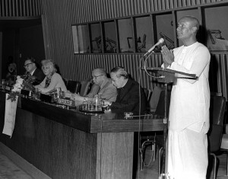  77-116-04-nov-15-CKG-meditates-conf-room-04-crp-resize.jpg
Mr. Peter Stewart, of the Thanks-Giving Foundation and Center for World Thanksgiving in Dallas, Texas
(which facilitated the 1985 gift to the UN from the USA, of Norman Rockwell’s famous mosaic, ‘The Golden Rule.’)
"Your celebration of prayer in the Meditation Room at the United Nations will be echoed by a celebration of gratitude at the
Meditation “Room of Quiet” sign
Upon entering the meditation “Room of Quiet” a sign states:
"This is a room devoted to peace
and those who are giving their lives for peace.
It is a room of quiet where only thoughts should speak."

Historic Talks
Among historic events in the first decades of the Peace Meditations at the UN, the 1980 talks on “The Inner Role of the United Nations” by Sri Chinmoy were of special interest.  Part 1 which took place on 6 June 1980 at the US State Department, Washington, D.C.; was also delivered at the UN Headquarters in New York, on 13 June 1980.  Part 2 of the same title was given on 16 June 1980, at the UN Office in Geneva. | 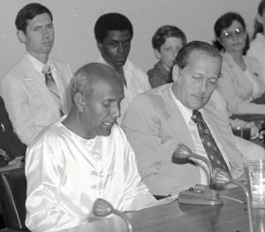  ED Note: used photo of talk at US State Department in Part 2 . excerpt from talk and picture of Kennedy and U Thant in excerpt
Excerpts from Talks:
“Inner Role of the UN” Part 1: 6 June 1980 at the US State Department, Washington, D.C.; also delivered at the UN Headquarters in New York, on 13 June 1980
“The term ‘united’ has always had a special appeal to all human souls, and this transcendent idea has remained in vogue down the sweep of centuries.
“The inner role of the United Nations amuses the intelligentsia, inspires the world-peace-lovers and nourishes the world-oneness-servers.
“The late President John F. Kennedy spoke not only to his fellow Americans but to all his fellow beings when he proclaimed:  ‘My fellow inhabitants of this planet, let us take our stand here in this assembly of nations. And let us see if we, in our own time, can move the world towards a just and lasting peace.’ | 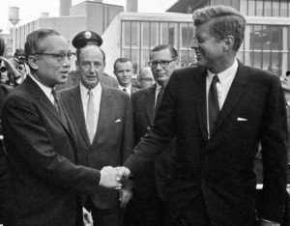1963-09-20-sep-un-photo-189364-Pres-John-F-Kennedy-bids-farewell-UN-SG-U-Thant-Amb-Adlai-Stevenson-behind-crp | 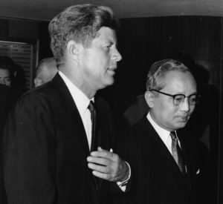  1963-09-20sep-un-photo-189363-NY049-SG-U-Thant-with-USA-president-J.F.Kennedy-arrival-un-hq-crp
“Inner Role of the UN” Part 2: 16 June 1980, at the UN Office in Geneva.
“The inner role of the United Nations is an inner cry and an outer smile. The inner cry has to climb up to reach the highest pinnacle. The outer smile has to reach the length and the breadth of the world. “The inner role of the United Nations is the link with the immortal power of infinite peace that spans the universe. It evolves slowly, steadily and unerringly.
“The inner role of the United Nations tells us that duty and responsibility have to be seen in a different light. We have come to realise that duty is nothing other than opportunity, and that responsibility is another name for privilege. “Therefore, to serve the United Nations’ unique capacity is to be blessed with a golden opportunity and fruitful privilege.
“The inner role of the United Nations tells us success is fleeting, whereas progress is everlasting.
“Oneness” as an encouraging goal
As we look to 2030 and beyond, we value. especially in challenging times, initiatives that bring us closer to a “Oneness” World. Efforts to strengthen communities by understanding different cultures, and by invoking a culture of peace give hope. The importance of personal poise and knowledge of when and how to practice patience is necessary.
Many found Sri Chinmoy’s talks provide a deep understanding and helpful approach to problems, expectations and opportunities of the international community. His answers to practical questions and daily office concerns were greatly valued.
Sri Chinmoy often used “Oneness ” to encourage or invoke a broad sense of identification with humanity and nature.  “Oneness” may provide opportunities for progress within challenge. | 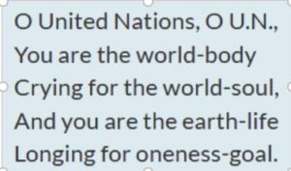  Excerpt from lyrics of ‘“O United Nations’“ by Sri Chinmoy, performed 28 October 1975 at “World Unity: The Song of the Soul”, a programme cosponsored by the Peace Meditation and dedicated to Music and World Peace, in the UN Dag Hammarskjold Auditorium

Examples of oneness expressed: ED Note: Need simple expressions to help illustrate “oneness
“When there is oneness, there is no feeling of supremacy. “ 17 May 1974 srichinmoylibrary.com/mun-120
“After an individual establishes his oneness with others, he feels their needs as his own.” 20 may 1977 srichinmoylibrary.com/mun-19
“Humanity is only our enlarged and expanded self. On the strength of our oneness we claim the body, heart and soul of the United Nations as our own. If we have this wider outlook and larger vision, all human beings are part and parcel of one universal family.” 18 April 1978 srichinmoylibrary.com/mun-119
” While working at the United Nations, we have to sing all the time in the inmost recesses of our heart the oneness-song.”. 16 November 1976 srichinmoylibrary.com/mun-93
“When we try to judge others or examine others, we immediately lose our sense of identification. But if we focus our attention on all things with the same amount of sympathy, love and concern, then we feel inside all things their basic oneness with everything else and with ourselves. “ July 26, 1974 srichinmoylibrary.com/tnh-25
“Unity is not oneness. A bud is not a flower. The presence of unity is the immediate end of human imperfection and limitation. The presence of oneness is the glorious beginning of man’s perfect Perfection. 14 April 1970 .srichinmoylibrary.com/gns-27
ED Note: How would you answer if delegate asked what did Sri Chinmoy mean when he said oneness? Do above quotes assist in answering the question?

Students of Peace
Through his activities, Sri Chinmoy was often referred to as “a Student of Peace”. We continue to learn and share peaceful ways towards a “Oneness world” via different approaches. In addition to talks and answered questions, some events presented in this booklet may be helpful. These examples will hopefully inspire more inner meditations and outer activities to bring us closer to a oneness world
50 years – past and future
Members of the UN community and especially the meditation group had opportunities for hours of silent meditations during the past fifty years.. Activities devoted to a oneness goal have lifted and sustained our deepest hopes. As an expression of our gratitude, we hope this booklet assists those continuing to aspire and serve the goals of the UN Charter, the Declaration of Human Rights and a “Oneness World” in the years ahead.
"Each nation has human beings who aspire for a better, more illumining and more fulfilling world. These seekers have expressed their aspiration in and through various fields: spirituality, religion, philosophy, science, music, art, poetry and so forth.  The United Nations is not only for the delegates and the representatives of the various nations. It is for all those who have aspired and do aspire and will always aspire." (/rd-8) | 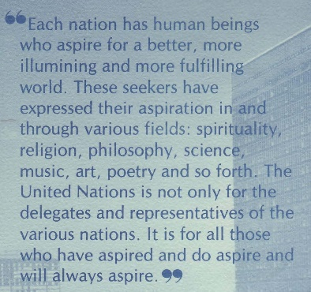
Welcome to Join
If you have the required pass for entry to UN premises we invite you to attend our regular meetings and/or be informed of special events. See contact information at the end off the Booklet
Those without access to the UN premises: working remotely; serving at country duty stations; traveling or for other reasons just want to feel connected even from a distance please see Section section Part 3-15 Building on inspiration to Join Weekly Meditation Sessions from Anywhere

Name* change 1970 to 1983: ED Note: Short or (part of) longer version – indicates 3 names / dates below):
*Originally referred to simply as the United Nations Meditation Group when it was founded in 1970, after a few years the group was officially renamed as “Sri Chinmoy: The Peace Meditation at the United Nations.“
Further detail Name change from 1970 to 1983:
*Originally referred to simply as the United Nations Meditation Group when it was founded in 1970, at the invitation of Secretary-General U Thant, after a few years the meditation group became more widely known among staff and delegates. Beyond meditations, the activities sometimes included musical offerings, talks or lectures, answers to questions on meditation, spirituality and the United Nations, and presentations on a theme. Special programmes for UN anniversaries and other occasions were many times co-sponsored by the diplomatic missions of the UN member states, as well as UN offices or other entities in the UN Community.
In response to increased inquiries about the Meditation Group, the office of the Secretary-General suggested mentioning Sri Chinmoy in the Group’s name to honour him as the founder and help indicate the standard and philosophy associated with the service being provided. With the agreement of Sri Chinmoy, and of the regular members and supporters of the group from the staff and diplomatic community, and with the approval of the UN office of Legal Affairs, from 1978 the group was referred to as “Sri Chinmoy: Meditation at the United Nations.”
A few years later in 1983, it was suggested to include the word “Peace” to further indicate the type of activity, again with the approval of the Office of Legal Affairs. Since then the group has been known as: “Sri Chinmoy: the Peace Meditation at the United Nations”.
See also next: Part 3-03 Highlight UN Anniversaries

See ‘The Vision of the United Nations: A Oneness-World-Family’
Part 1, Questions Answered; and
Part 2, Talks
Below items considered for Part 3-02 but removed from draft.
Some might be used in other sections..or to indicate ideas of what might also be considered. Useful to review again when the completed Draft of all parts of Part 3 are close to completion.

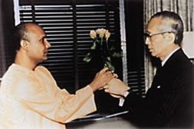 uthant-sri-chinmoy-photo-meet-flower-silence-1972-feb-29 102kb Note: b/w photo has definition and better with this Hist presentation? |  | 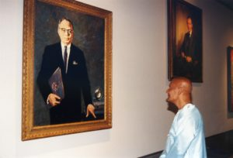 ny312-ckg-look-uthant-portrait-third UN Secretary-General. (20 mb
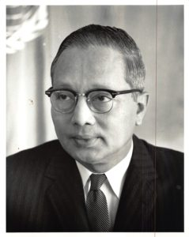 ny312-ckg-look-uthant-portrait-third UN Secretary-General. (20 mb)j_26260" NY047-SG-U-Thant-Portrait-1965-Sep -un photo caption-says-92603 | U-Thant-Award-booklet-color-4-page-2006[/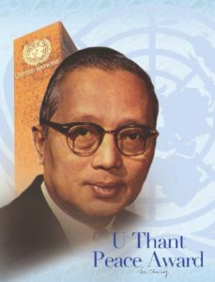 |  | 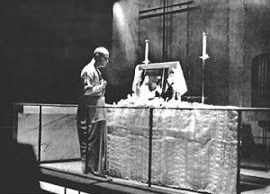 uthant-sri-chinmoy-photo-meditation-church-center-uthant-passing-2007
==For more on Wainwright house and Huckelbee
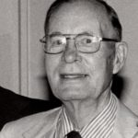1977-08-10aug-rye-ny-med-room-un-mr-huckabbe-crp | 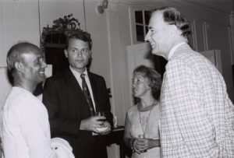1977-08-10aug-sri-chinmoy-with-Alfred-Sunder-wainwright-house-others-at-Prog-honour-original-med-room-at-un | 1977-08-10aug-rye-ny-med-room-un-after-event-wainwright-house-Sri-Chinmoy-Mr-and-Mrs-Muller 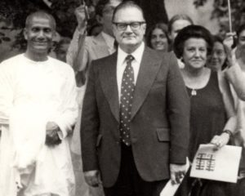
For more on Wainwright event see Periodic Bulletin "Meditation at the United Nations" August 1977 ;
ED NOTE: For more info while finalizing this page, also see these links:

https://www.srichinmoypeacemeditationatun.org/1977/08/10/b-excerpts-on-history-of-meditation-room-wainwright-house-aug-10-1977/

B. Excerpts on History of meditation Room – Wainwright House, Aug 10 1977

C. Extended remarks from 10 Aug 1977 – more history on UN Meditation Room
or Periodic Bulletin "Meditation at the United Nations" August 1977
PDF version: bu-scpmaun-1977-08-27-vol-05-n-08-aug-ocr-opt

