Inspirational History for the UN Community

Outer environment and inner support for prayer, meditation and reflection

with contribution by Sri Chinmoy: the Peace Meditation at the United Nations.

Contents (may be after first Paragraphs)
Contents
Remember the Past to Inspire the Future 2
League of Nations and UN 2
The world is making observable outer Progress 3
Reflection supported since UN’s Beginning. 3
Silence opens and closes UN General Assembly 3
Trygve Lie 3
Dag Hammarskjold 3
Brief history of beginning of Peace Meditation Group at the UN 5
1968 Excerpts from Sri Chinmoy's first talk to UN Community: 5
The Song Universal 5
This first talk is significant for several reasons 5
April 1970, Begin ongoing Peace Meditations led by Sri Chinmoy at the UN. 7
Inauguration Meditation April 1970 (excerpt) 7
First Invitation to Join from afar 7
Dag Hammarskjold Remembered 8
29 Jul 1977, Secretary-General Dag Hammarskjold’s birthday was observed. 8
Excerpts from sign outside the Mediation Room of Quiet 8
Early Meditation Room Friends Honored 9
Robert Muller, UN, Deputy Under-Secretary-General 9
Mr . Weyman Huckabee, Laymen’s Movement Executive Director from 1941 to 1969 9
20th Anniversary of the redesign of the Meditation “Room of Quiet” 10
First, A few minutes of silence was observed in the small but symbolic Meditation “Room of Quiet” 10
The formal programme took place in Conference Room 4. 10
Monsignor Giovanni Cheli 11
H.E. Dr. Carlos P. Romulo 11
Mr. Robert Muller, 11
Mrs. Judith Hollister 12
Excerpts from Statements 12
Historic Talks 13
“The Inner Role of the United Nations 13
Excerpts from Talks 13
“Oneness” as an encouraging goal 14
Examples of oneness expressed: 14
Students of Peace 15
50 years – past and future 15
Welcome to Join 15
Name* change 1970 to 1983: 16
SC: PM at UN use of “Leader” or “Teacher” 16

Remember the Past to Inspire the Future

"If we say that the United Nations is the result of the twentieth century awakening, then we are mistaken. The United Nations is the outgrowth of the inner awakening of human beings from time immemorial." – Sri Chinmoy (/rd-8)

Let us be grateful for the deeply connected histories of the United Nations, founded in 1945, and the Peace Meditation Group, which came into being 25 years later. Let us appreciate the multi-generational efforts that have resulted in real progress since then.
“I am rarely enthusiastic about what the League of Nations has done or not done, but I am always thankful that it exists.” - Albert Einstein (hhi-38)

League of Nations and UN
The world made a brave attempt at international progress towards peace through the League of Nations, which Sri Chinmoy deeply appreciated. The vision of the League was later carried forward and expanded by the United Nations Charter and the Universal Declaration of Human Rights.  “The League of Nations was transformed into reality and became the United Nations. (tnh-21)  “The United Nations has abundant capacity to fulfil the dream of the League of Nations and also to fulfil its own dream, which is far more absorbing, more illumining and more fulfilling.” -(mun-73) | 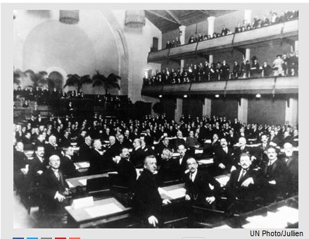  League-of-Nations-at-opening-session-Geneva-1920-nov-15-un-photo-julian-97289.jpg 41 KB 41kb[/caption]
“The League of Nations was a dream-seed. The United Nations is a reality-plant. The aspiring and serving life of man's universal oneness will be the eternity-tree. (tnh-1) |  | A League of Nations is like a cluster of flowers. A United Nations arranges the flowers harmoniously. In a Oneness-world, we will see all as one whole.” - (mun-78)
This hope and aspiration is now also expressed in more detail through the Sustainable Development Goals (SDGs)*. See End Note 1 and Full text of Goals at: https://www.un.org/sustainabledevelopment

The world is making observable outer Progress
Reflection supported since UN’s Beginning. | 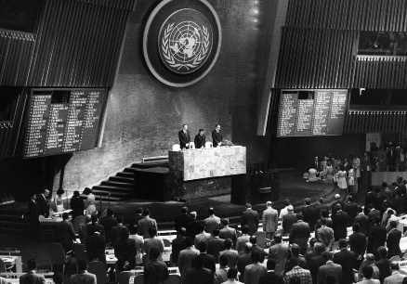  un-photo-247181-open-ga-minute-silence-1975-Teddy-Chen-crp.jpg 1mb

Silence opens and closes UN General Assembly
Since the earliest days, the annual UN General Assembly sessions have opened and closed with an invitation to all delegates to observe one minute of silence dedicated to prayer or meditation.

See End Note 2 Rule 62 Procedure of General Assembly

The first and second UN Secretaries-General, Trygve Lie and Dag Hammarskjöld, established and redesigned the Meditation Room – “A Room of Quiet” located adjacent to the General Assembly public lobby.

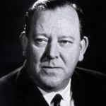 UN-photo-54480-Trygve-Lie-Norway-1st-UN-SG-Feb-1946-Apr-1953-crop.jpg | Trygve Lie  Lie, Trygve Lie!  O UN Boat’s first pilot high.  Dauntless you fought for your ideal sky.  Lie, Trygve Lie!  O Oslo, Norway’s ‘peace mission’ son.  The world salutes your Spirit’s run.  Lie, Trygve Lie!  - Words by Sri Chinmoy | 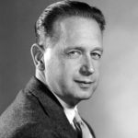  UN-Photo-60981-Dag-Hammarskjöld-2nd-SG-10-Apr-1953-18-Sep-1961-2mb | Dag Hammarskjold  Dag Hammarskjold, purity-gold!  Divinity’s reality bold.  Your peerless vision cosmic-run  Ceaselessly cried for perfection-sun.  In you the UN glory’s-height  Of silence light and delight.  -Words by Sri Chinmoy
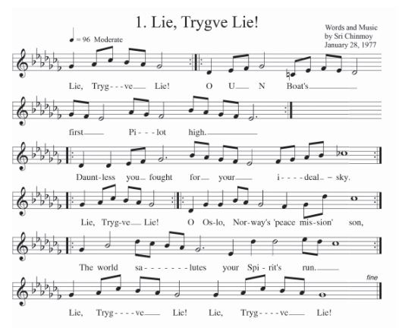 |  | -  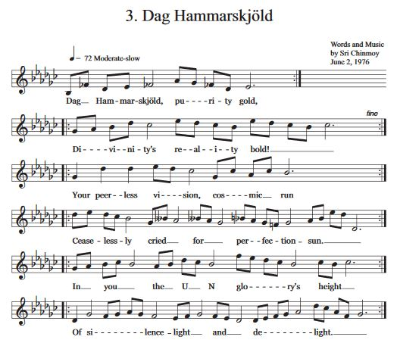

"]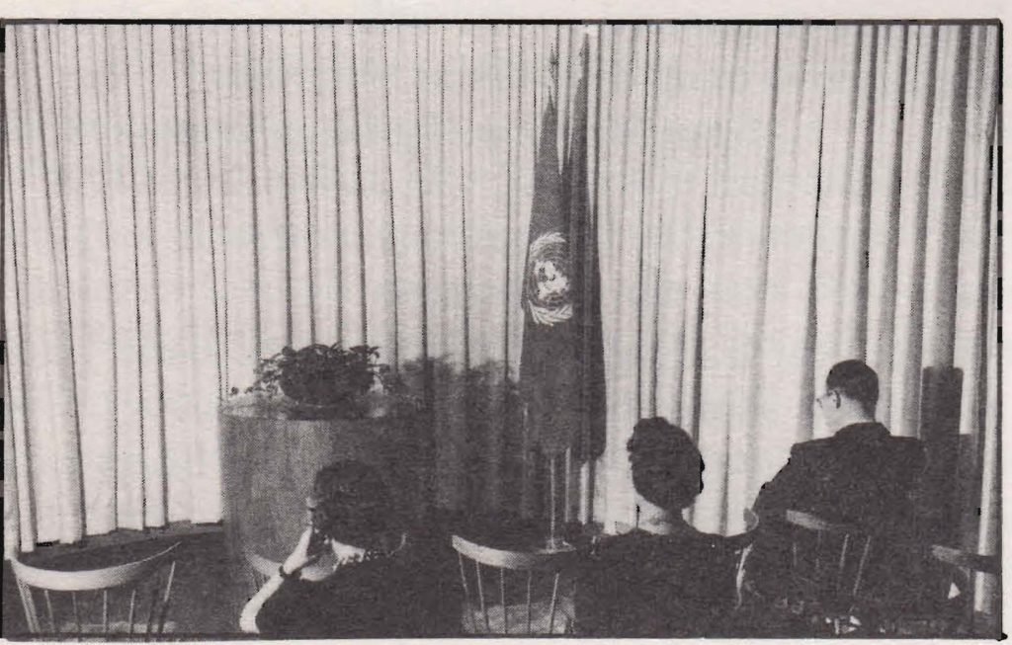
A view of the original Meditation Room at the 1940’s United Nations Headquarters in Lake Success, New York. pmaun-rpt-1977_Page_19-photo-orig-med-rm-top-no-label.jpg 540 KB

Brief history of beginning of Peace Meditation Group at the UN
Sri Chinmoy’s first talk at the United Nations, “The Song Universal,” was offered the evening of 26 November 1968  The event was arranged by a husband and wife who felt Sri Chinmoy’s message would be welcomed by the UN Community.  The invitation that went out had a photo of Sri Chinmoy with folded hands, with some biographical information as well. | 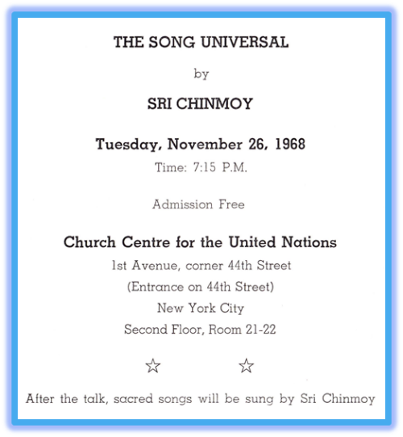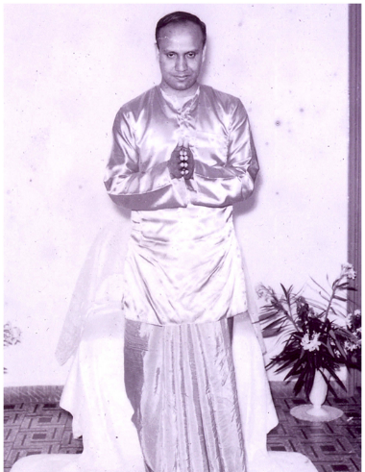

1968 Excerpts from Sri Chinmoy's first talk to UN Community:
In November of 1968, Sri Chinmoy was invited to give a talk to the UN Community in New York. "The Song Universal" shared the necessity of feeling the entire world as one’s real home. The importance of peace, oneness and deep appreciation of various religious faiths was also expressed. A few excerpts of the talk follow:

The Song Universal
"The Song Universal is freedom. Freedom from what? Freedom from limitations, freedom from imperfections and freedom from ignorance.
"Freedom does not mean being away from home. Freedom means accepting and feeling the entire world as one's real home, as one's very own.
"Our inner realisation and outer action must run abreast. Outer achievements should be the conscious and spontaneous revelation of the inner divinity.
"Love, harmony, peace and oneness. ... On the strength of his inner mounting flame, aspiration, man can easily, unerringly and spontaneously manifest these ideals...in every sphere of life.
“It is quite natural and proper that we should discover our God in and through our own religion. When we go deep within we come to realise that there is only one religion, and that religion is man's inmost cry for God-Realisation.

- Sri Chinmoy at the Church Center for the United Nations, November 26, 1968. Printed in The Garland of Nation-Souls, Agni Press, 1972 , Full talk at https://www.srichinmoylibrary.com/gns-4

This first talk is significant for several reasons
It was after this lecture on 26 November 1968 that Sri Chinmoy’s relationship with UN Secretary-General U Thant started blossoming,  At U Thant’s request, his Chef de Cabinet C.V. Narasimhan interviewed Sri Chinmoy and spoke very highly of him to the Secretary-General.  Mr. Narasimhan later conveyed messages between the two men, including U Thant’s encouraging invitation, for the establishment of the Meditation Group at the UN on 14 April 1970. |  | 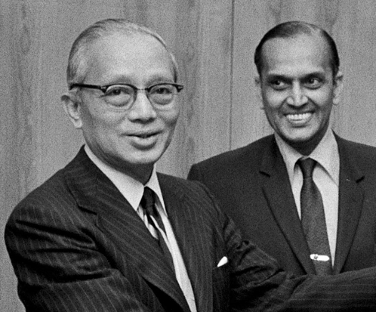  Secretary-General U Thant and Chef de Cabinet C.V. Narasimhan 12 December 1971UN-Photo# 177105
Many years later, Under-Secretary-General C.V. Narasimhan was a special guest at Sri Chinmoy’s Peace Concert in the Dag Hammarskjold Auditorium on 6 Dec 1993.  Mr, Narasimhan was very proud of his role, remarking that “In the early days when U Thant was Secretary-General, I had a little role to play in having this Meditation Centre led by Sri Chinmoy in the United Nations as part of our ongoing activities.” | 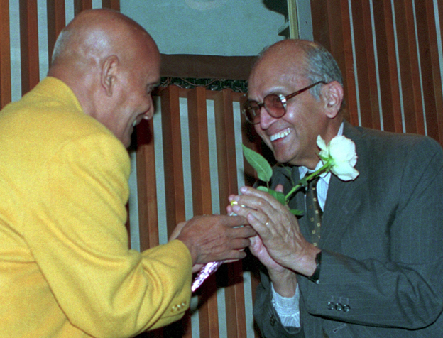  Sri Chinmoy and C.V. Narasimhan
.
As a Buddhist and a Hindu, respectively, U Thant and Narasimhan both valued a spiritual approach to world affairs.  Sri Chinmoy called Narasimhan “U Thant’s dearest colleague, his most valued friend, his confidant.” |  | 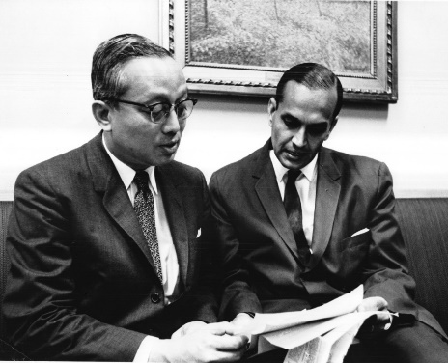  UN Photo Secretary-General U Thant and C.V. Narasimha
And it seems that from Sri Chinmoy’s first talk at the UN, together with subsequent interchanges, they both felt that Sri Chinmoy would further and support their own spiritual views and visions of the UN. which Sri Chinmoy poetically referred to as | 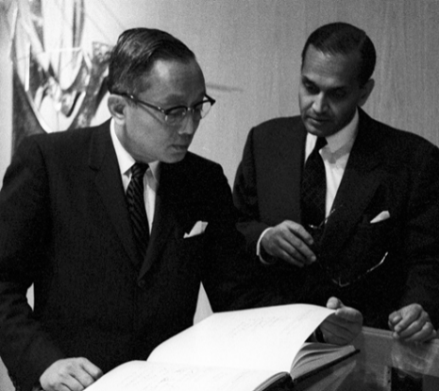  Acting-Secretary-General U Thant and USG, Chef de Cabinet ,C.V. Narasimha 02 Nov-1962 Looking at UN Charter in lobby of General Assembly Building. UN Photo 373013
“United Nations:
the Heart-Home
of the World Body.”
* * * * * * * * * * * *

April 1970, Begin ongoing Peace Meditations led by Sri Chinmoy at the UN.
In 1970, the third UN Secretary-General, U Thant invited spiritual leader Sri Chinmoy to offer regular meditations for staff and delegates at UN Headquarters.  Inauguration Meditation April 1970 (excerpt)  “Today's United Nations was yesterday's perfecting Vision. Tomorrow's United Nations is today's fulfilling Realisation.  “Unity is not oneness. A bud is not a flower.  “The presence of unity is the immediate end of human imperfection and limitation. The presence of oneness is the glorious beginning of man's perfect Perfection.  - Sri Chinmoy, 14 April 1970, Printed in The Garland of Nation-Souls, Agni Press, 1972, srichinmoylibrary.com/gns-27 | 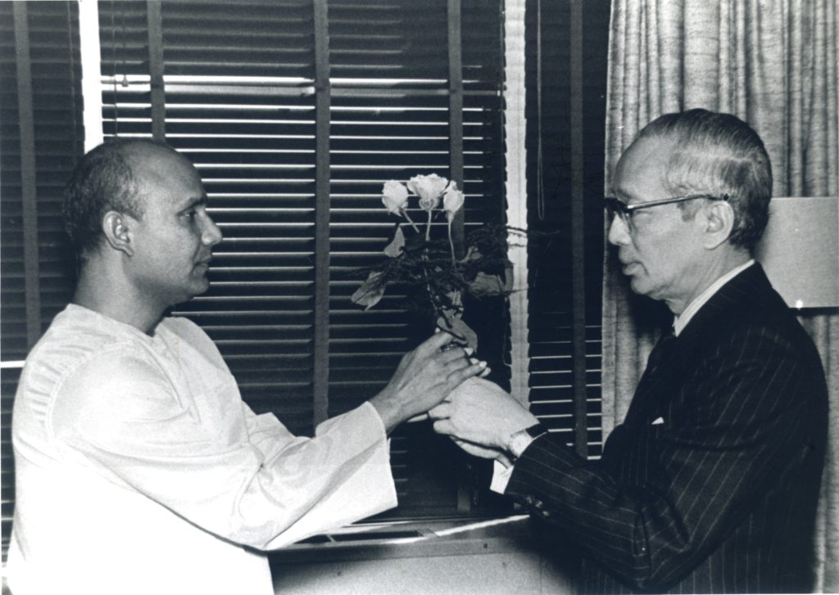  ny235-1972-02-29-Sri-Chinmoy-with-SG-UThant.jpg (24 MB)

This began decades of contemplative events and programmes by Sri Chinmoy and the meditation group at the UN. Some highlights, excerpts and photos are included in this booklet

First Invitation to Join from afar:
After that 1970 first inaugural meditation at the UN, Sri Chinmoy invited and encouraged his students, friends and others to value the UN efforts and to join the meditations inwardly when possible on Tuesday.
"The United Nations serves a most significant role in the unification of human wisdom, concern, sympathy and love. Every Tuesday they have given me the honour of conducting this meditation. Identify yourselves with us, no matter where you are or what you are doing. If you are in the office or if you are in the bank, if you are in publishing premises or you are in the hospital, working there, you can send your aspiring soul to us, to meditate with us. The physical can remain there, but the spirit can be with us while all are united in meditation.”

Dag Hammarskjold Remembered

29 Jul 1977, Secretary-General Dag Hammarskjold’s birthday was observed.
Peace Meditation Group members joined Sri Chinmoy to observe a few minutes of silence in the small but symbolic meditation “Room of Quiet”, re-designed by Dag Hammarskjold in 1957.  The Group then held a programme in the UN Dag Hammarskjold Library Auditorium which included meditation, a talk, instrumental and vocal arrangements of a song by Sri Chinmoy dedicated to Dag Hammarskjold, a choral reading of Hammarskjold’s writings, and tributes. | 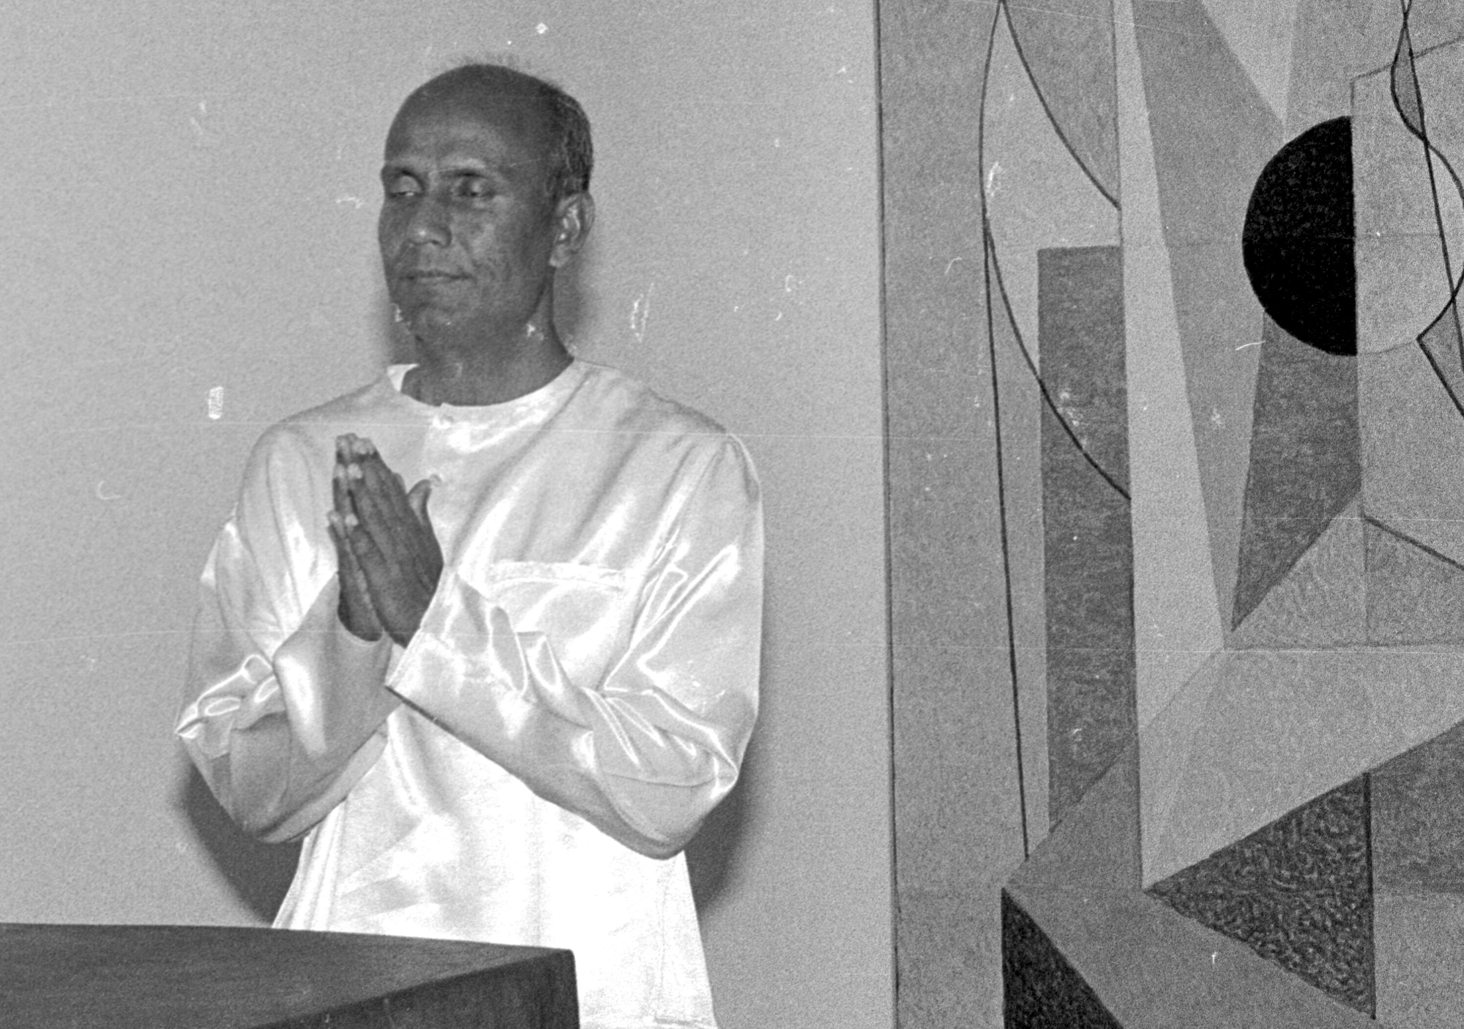  1977-07-29-04-ckg-room-of-quiet-med-room-honor-day-ham.BIG

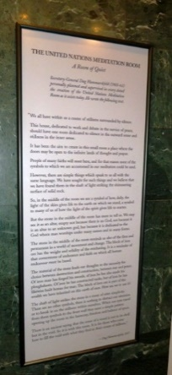  Possibly use a photo that shows a bit of door next to sign – shot from straight ahead or angle showing some of stain glass window beside door | Excerpts from sign outside the Mediation Room of Quiet  “We all have, within us a centre of stillness surrounded by silence. This house, dedicated to work and debate in the service of peace, should have one room dedicated to silence in the outward sense and stillness in the inner sense. It has been the aim to create in this small room a place where the doors may be open to the infinite lands of thought and prayer.  “People of many faiths will meet here, and for that reason none of the symbols to which we are accustomed in our meditation could be used. “… man worships under many names and in many forms. The block of iron ore has the weight and solidity of the everlasting. It is a reminder of that cornerstone of endurance and faith on which all human endeavour must be based.  “There is an ancient saying that the sense of a vessel is not in its shell but in the void. So it is with this room. It is for those who come here to fill the void with what they find in their centre of stillness.” – Dag Hammarskjold, UN Secretary General, 1953 – 1961 Upon entering, a sign inside states:  "This is a room devoted to peace and those who are giving their lives for peace.  It is a room of quiet where only thoughts should speak."

Early Meditation Room Friends Honored  On 10 August 1977, at the Wainwright House in Rye, New York, speakers from the UN and the Wainwright House honoured Weyman C. Huckabee, the Laymen’s Movement Executive Director from 1941 to 1969, for his part in the encouraging a Meditation Room at the UN and the UN to open and close its General Assembly Meetings by observing a moment of silence.  The programme opened with silent meditation, followed by musical selections played by Sri Chinmoy on the Indian esrai.  The involvement of the Friends of the Meditation Room and the Laymen‘s Movement in early years to establish the Meditation Room at UN in New York were honored. Members of the Meditation Group at UN were invited as special guests. | 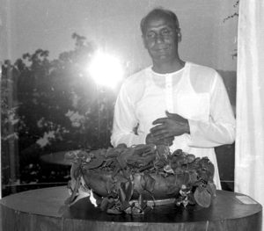  Sri Chinmoy with furnishings from 1940s Original Meditation Room at Headquarters in Lake Success NY, preserved at Wainwright House, Rye NY. 1977-08-10-14-sri-chinmoy-in-room-orig-un-med-furrnishing-alter-small-plaque-right-scaled.jpg

Robert Muller, UN, Deputy Under-Secretary-General :
“When I learned that the old Meditation Room from Lake Success was here in Rye, I tried to remember as many details as possible of the first premises of the United Nations on Long Island. I found that I was unable to remember the hall of the General Assembly, the Security Council and even my own office. But when it came to the Meditation Room, I remembered many details. I could see clearly the large tropical tree trunk from Africa, the bowl of flowers or greenery on top of it and the semicircular rows of chairs for the visitors.
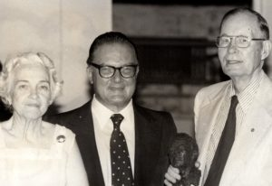  1977-08-10aug-rye-ny-med-room-un-r-mwller-mr-mrs-huckabbe-holding-small-bust-crp-scaled | “Tonight, after thirty years, I saw it again and I was struck by the accuracy with which it had remained engraved in my memory. I am therefore tempted to believe that despite all the attractions of material life and the fascination of new knowledge, spirituality and its symbols go much deeper and leave an extraordinary, indelible mark in us. Yes, I lived a very rare moment tonight, rediscovering emotions and images which were a third of a century old."

Mr . Weyman Huckabee, Laymen’s Movement Executive Director from 1941 to 1969:
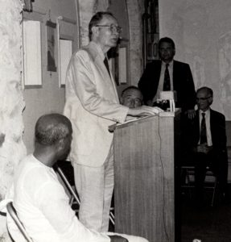  1977-08-10aug-rye-ny-med-room-un-Weyman-C-Huckabee-Laymen's-Movement-Executive-Dir-1941-1969 speaks | "one experience ... has to do with my meeting Pope Pius the XII when I was given a private audience to talk with him about the Meditation Room in the United Nations and about the day of prayer set aside for prayer and meditation for world peace. He received me warmly.  “ I asked why there was still so much violence in the world in spite of the efforts made to bring peace. He said, 'That is a very difficult question.' “Then, after a pause he continued, ‘Because , even though we know the Truth, we do not abide by it.’  “I am very happy to be here. ... I am grateful for your love, for your concern and for your friendship."  For more on Wainwright event see Periodic Bulletin "Meditation at the United Nations" August 1977
ED NOTE: For more info while finalizing this page, also see links on "Considered but not used" page:

20th Anniversary of the redesign of the Meditation “Room of Quiet”
On 15 November 1977, a programme sponsored by the Peace Meditation Group marks the 20th Anniversary of the redesign of the Meditation “Room of Quiet” adjacent to the UN General Assembly Lobby,  This space was redesigned by Dag Hammarskjöld in 1957.  First, A few minutes of silence was observed in the small but symbolic Meditation “Room of Quiet”  The formal programme took place in Conference Room 4. | 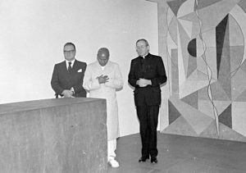  (Shown left to right, Robert Muller, UN Deputy Under-Secretary-General; Sri Chinmoy, leader of the Peace Meditation Group; and Monsignor G. Cheli, Permanent Observer of the Holy See to the UN). 1977-11-15-06. room of Quiet redesign anniversary R-Muller-Sri-Chinmoy- G-Cheli-silence-13 MB
Speakers at the observance in Conference Room 4 included: Mr. Robert Muller; Msgr. G. Cheli; Mr. C. P. Romulo, Secretary of Foreign Affairs of the Philippines, (and an original signer of the UN Charter); Judith Hollister, Representative of Wainwright House (where the furnishings from the first meditation room at the UN’s early Headquarters at Lake Success, were displayed in 1977). Mrs. Hollister was also founder and leader of the interfaith organization: “Temple of Understanding” .
Statements were provided by: Mr. Andrew Young, Permanent Representative of the United States to the United Nations. Cardinal T. Cooke, Archbishop of New York; Mr. Peter Stewart, of the Thanks-Giving Foundation in Dallas, USA (which was responsible for the 1985 Fortieth Anniversary gift to the UN from the USA, of Norman Rockwell’s famous mosaic, ‘The Golden Rule - Do Unto Others.’)
The Meditation Group Choir performed songs composed by Sri Chinmoy, which included words of several UN Secretaries-General set to music.
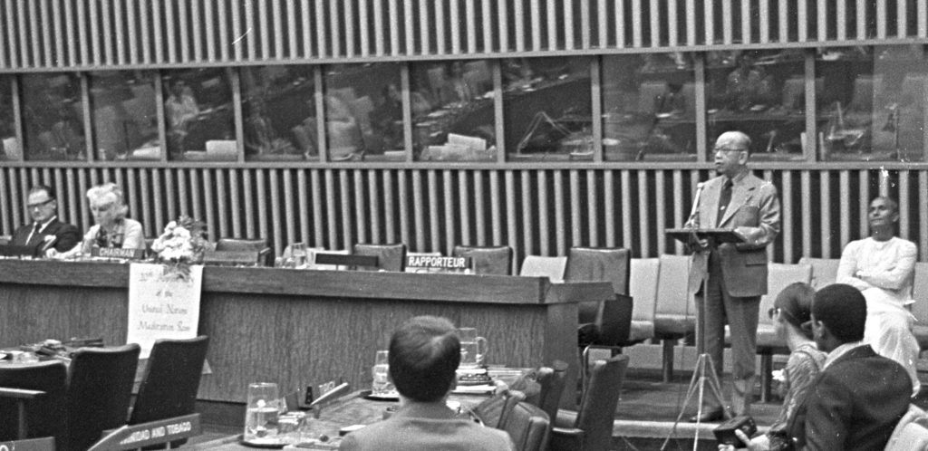

1977-11-15-02-1-Room-of-quiet-anniversary-Romulo-phillipines-speaks-crp-scaled 582kb -see to crop (1977-11-15-02-1.jpg romulo-speak-crop-with-panel (13 MB)
Excerpts from event: (Ed note: might not need full title if full used above):

Monsignor Giovanni Cheli, Permanent Observer of the Holy See
"Silence is like a friend. It must be cultivated . If we wish meditation to flourish within us, we need to help it to grow. We can do that only by setting aside times in our day when we can pay attention to the quiet within us so that we renew our awareness of its beauty and its grandeur."
H.E. Dr. Carlos P. Romulo, Secretary of Foreign Affairs of the Philippines (and an original signer of the UN Charter in San Francisco)
"The United Nations is a centre for harmonizing action, as the Charter continually reminds us. But the process of harmonizing is a difficult one. All too often passion and conflict rule the day. It is at such moments that we need the Meditation Room to look into ourselves and to encounter our God, so that we may cleanse our spirit and gain needed strength. This I have done many times."  "Thousands have visited the Meditation Room and no doubt thousands of others will do so in the future. They will sit there in silent communion, seeking refuge from the turmoil and, more important, seeking guidance and light and refreshment of the spirit." | 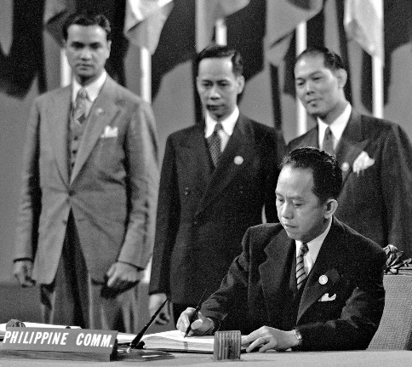  1945-06-26jun-sign-un-charter-un-photo#235948-Philippines-Carlos-P.Romulo-Chair-Delegation-Philippine-sign-

Mr. Robert Muller, Deputy Under-Secretary General for Inter-Agency Affairs and Coordination
"For me, the tall building of the UN is an edifice of human hope and dream jutting into the universe and receiving from that universe increasingly clearer messages.
“ Year-round people from all creeds and cultures assemble here to design a better future for the world. And in my opinion they will succeed. Once again, but this time on a universal scale, mankind is seeking no less than its reunion with the divine,”
Mrs. Judith Hollister, Representative of the Wainwright House*
"As time goes by, people often forget the original pioneers behind, for instance, the Meditation Room.
“The Friends of the Meditation Room had the concept of a holy, quiet, sacred area connected with the UN way back in the days of Lake Success.
“And today we rejoice in this miracle, and even today is a miraculous day. Thank you."
*Mrs. Hollister was also founder and leader of the interfaith organization: “Temple of Understanding”.
 | Excerpts from Statements received for event:  H.E. Mr. Andrew Young, Permanent Representative of the United States to the United Nations.  "Away from the formality and routine aspects of our diplomatic activity, there is a great need for this room where we can absorb ourselves in private meditation and prayer. I pray that the tranquility of the “Room of Quiet ” transcends throughout the world and provides the inspiration for peace and brotherhood."  His Eminence, Cardinal Terence I Cooke, Archbishop of New York , entitled “Reflection on Silence”:  "I feel a need for and value opportunities for prayerful silence. In silence, I realize that the values and convictions that can easily be broken by the hard experiences of life are of great importance- such convictions as: it is good to be selfless; to be sad with those who mourn; to hunger and thirst for justice; to be pure in heart; to be merciful; to be a peacemaker. | below ,should lighten photo  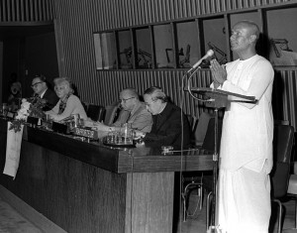  77-116-04-nov-15-CKG-meditates-conf-room-04-crp-resize.jpg  L to R: Robert Muller, Judith Hollister, Carlos P .Romulo , Giovanni Cheli, Sri Chinmoy

Mr. Peter Stewart, of the Thanks-Giving Foundation* and Center for World Thanksgiving in Dallas, Texas
"Your celebration of prayer in the Meditation Room at the United Nations will be echoed by a celebration of gratitude at the Chapel of Thanksgiving for this landmark of the human spirit.  (*Thanks-Giving Foundation facilitated the 1985 Fortieth Anniversary gift to the UN from the USA, of Norman Rockwell’s famous Mosaic: ‘The Golden Rule.- Do Unto Others’.) | Chapel at Thanksgiving-Square, Dallas Texas. | 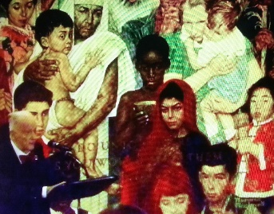  Section of Norman Rockwell’s Popular Mosaic at the UN: ‘The Golden Rule.- Do Unto Others’.)

Historic Talks
Among historic events in the first decades of the Peace Meditations at the UN, the 1980 talks on  “The Inner Role of the United Nations” by Sri Chinmoy were of special interest.  Part 1 which took place on 6 June 1980 at the US State Department, Washington, D.C.; was also delivered at the UN Headquarters in New York, on 13 June 1980.  Part 2 of the same title was given on 16 June 1980, at the UN Office in Geneva. | 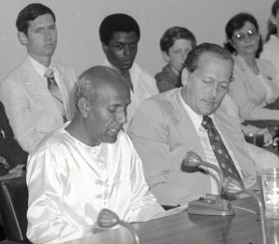
Excerpts from Talks:
“Inner Role of the UN” Part 1: 6 June 1980 at the US State Department, Washington, D.C.; also delivered at the UN Headquarters in New York, on 13 June 1980
“The term ‘united’ has always had a special appeal to all human souls, and this transcendent idea has remained in vogue down the sweep of centuries.
“The inner role of the United Nations amuses the intelligentsia, inspires the world-peace-lovers and nourishes the world-oneness-servers.
“The late President John F. Kennedy spoke not only to his fellow Americans but to all his fellow beings when he proclaimed:  ‘My fellow inhabitants of this planet, let us take our stand here in this assembly of nations. And let us see if we, in our own time, can move the world towards a just and lasting peace.’ | 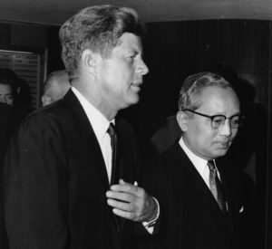1963-09-20sep-un-photo-189363-NY049-SG-U-Thant-with-USA-president-J.F.Kennedy-arrival-un-hq-crp | 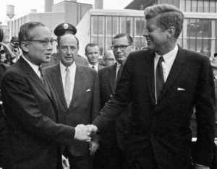1963-09-20-sep-un-photo-189364-Pres-John-F-Kennedy-bids-farewell-UN-SG-U-Thant-Amb-Adlai-Stevenson-behind-crp
“Inner Role of the UN” Part 2: 16 June 1980, at the UN Office in Geneva.
“The inner role of the United Nations is an inner cry and an outer smile. The inner cry has to climb up to reach the highest pinnacle. The outer smile has to reach the length and the breadth of the world. “The inner role of the United Nations is the link with the immortal power of infinite peace that spans the universe. It evolves slowly, steadily and unerringly.
“The inner role of the United Nations tells us that duty and responsibility have to be seen in a different light. We have come to realise that duty is nothing other than opportunity, and that responsibility is another name for privilege. “Therefore, to serve the United Nations’ unique capacity is to be blessed with a golden opportunity and fruitful privilege.
“The inner role of the United Nations tells us success is fleeting, whereas progress is everlasting.

“Oneness” as an encouraging goal
As we look to 2030 and beyond, we value. especially in challenging times, initiatives that bring us closer to a “Oneness” World. Efforts to strengthen communities by appreciating different cultures, and by invoking a culture of peace, give hope. The importance of personal poise and knowledge of when and how to practice patience is necessary.
Many found Sri Chinmoy’s talks provide a deep understanding and helpful approach to problems, expectations, and opportunities of the international community. His answers to practical questions and daily office concerns are greatly valued.
Sri Chinmoy often used “Oneness” to encourage or invoke a broad sense of identification with humanity and nature. This awareness of an expanded self, intertwined with other people, creatures, and things, could enhance our individual self’s ability to responsibly contribute to the world.  “Oneness” facilitates progress within challenges. | 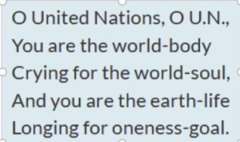  Excerpt from lyrics of ‘“O United Nations’“ by Sri Chinmoy, performed 28 October 1975 at “World Unity: The Song of the Soul”, a programme cosponsored by the Peace Meditation and dedicated to Music and World Peace, in the UN Dag Hammarskjold Auditorium
Examples of oneness expressed: ED Note: Is there a better order to help illustrate “oneness? Should some be moved to end note?
“When there is oneness, there is no feeling of supremacy. “ 17 May 1974 (/mun-120)
“After an individual establishes his oneness with others, he feels their needs as his own.” 20 may 1977 (/mun-19)
“Humanity is only our enlarged and expanded self. On the strength of our oneness we claim the body, heart and soul of the United Nations as our own. If we have this wider outlook and larger vision, all human beings are part and parcel of one universal family.” 18 April 1978 (mun-119)
” While working at the United Nations, we have to sing all the time in the inmost recesses of our heart the oneness-song.”. 16 November 1976 (mun-93)
“When we try to judge others or examine others, we immediately lose our sense of identification. But if we focus our attention on all things with the same amount of sympathy, love and concern, then we feel inside all things their basic oneness with everything else and with ourselves. “ July 26, 1974 (/tnh-25)
“Unity is not oneness. A bud is not a flower. The presence of unity is the immediate end of human imperfection and limitation. The presence of oneness is the glorious beginning of man’s perfect Perfection. 14 April 1970 (/gns-27)
“The outer message of the United Nations is Peace. The inner message of the United Nations is Love. The inmost message of the United Nations is Oneness. Peace we feel. Love we become. Oneness we manifest. (tnh-1)

ED Note: How answer if delegate asked what Sri Chinmoy mean when said oneness? Do above quotes assist in answering.?

Students of Peace
Through his activities, Sri Chinmoy, in his humble way, was happy to be known as “a Student of Peace”.
“In all sincerity I wish to tell you all that I am not a teacher of peace and I am not an ambassador of peace. What I am is a student of peace. A student of peace has the opportunity to learn and unlearn. A student of peace learns how to receive divine qualities from his Inner Pilot and he learns how to listen in the inmost recesses of his heart to the blessingful Messages of his Inner Pilot. Again, he unlearns the experiences of division and supremacy that the mind has given him over the years. The mind has taught us the song of supremacy as well as many other undivine lessons. The mind has given us many unfortunate experiences. As a student of peace, these lessons and experiences I try to unlearn.
“The experiences of the heart strengthen us, expand our horizons, make us feel that we are all one family and we have only one home. Our life-tree has countless branches, flowers and fruits. Each individual is a beautiful, beautiful flower with fragrance. Each individual is a sweet, delicious fruit of that life-tree. Jan 1993 (/pbp-1)
We continue to learn and share peaceful ways towards a “Oneness world” via different approaches. In addition to talks and answered questions, some events presented in this booklet may be helpful. These examples will hopefully inspire more inner meditations and outer activities to bring us closer to a oneness world.
50 years – past and future
Members of the UN community and especially the meditation group had opportunities for hours of silent meditations during the past fifty years. Activities devoted to a oneness goal have lifted and sustained our deepest hopes. As an expression of our gratitude, we hope this booklet assists those continuing to aspire and serve the goals of the UN Charter, the Declaration of Human Rights and a “Oneness World” in the years ahead.
"Each nation has human beings who aspire for a better, more illumining and more fulfilling world. These seekers have expressed their aspiration in and through various fields: spirituality, religion, philosophy, science, music, art, poetry and so forth.  The United Nations is not only for the delegates and the representatives of the various nations. It is for all those who have aspired and do aspire and will always aspire." (/rd-8) | 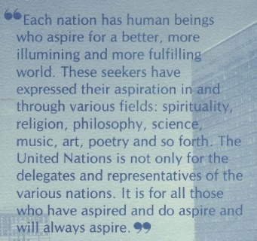

Welcome to Join
If you have the required pass for entry to UN premises we invite you to attend our regular meetings and/or be informed of special events. See contact information at the end of the Booklet.
Those without access to the UN premises: working remotely; serving at country duty stations; traveling or for other reasons just want to feel connected even from a distance please see section Part 3-15 Building on inspiration to Join Weekly Meditation Sessions from Anywhere. Individuals outside the UN community have joined inwardly since the early days of the mediation group at the UN in 1970. This identification, inner support and sharing of good will is greatly appreciated .

Name* change 1970 to 1983:
ED Note: Short or (part of) longer version /– indicates 3 names / dates below):
*Originally referred to simply as the United Nations Meditation Group when it was founded in 1970, after a few years the group was officially renamed as “Sri Chinmoy: The Peace Meditation at the United Nations.“
Further detail Name change from 1970 to 1983:
*Originally referred to simply as the United Nations Meditation Group when it was founded in 1970, at the invitation of Secretary-General U Thant, after a few years the meditation group became more widely known among staff and delegates. Beyond meditations, the activities sometimes included musical offerings, talks or lectures, answers to questions on meditation, spirituality and the United Nations, and presentations on a theme. Special programmes for UN anniversaries and other occasions were many times co-sponsored by the diplomatic missions of the UN member states, as well as UN offices or other entities in the UN Community.
In response to increased inquiries about the Meditation Group, the office of the Secretary-General suggested mentioning Sri Chinmoy in the Group’s name to honour him as the founder and help indicate the standard and philosophy associated with the service being provided. With the agreement of Sri Chinmoy, and of the regular members and supporters of the group from the staff and diplomatic community, and with the approval of the UN office of Legal Affairs, from 1978 the group was referred to as “Sri Chinmoy: Meditation at the United Nations.”
A few years later in 1983, it was suggested to include the word “Peace” to further indicate the type of activity, again with the approval of the Office of Legal Affairs. Since then the group has been known as: “Sri Chinmoy: the Peace Meditation at the United Nations”.

SC: PM at UN use of “Leader” or “Teacher”
Possible Draft brief sentence to consider: : In the early 1970s some individuals and publications referred to Sri Chinmoy as “Director” of the Meditation Group at the UN. It became clear that "leader” or “teacher” was more appropriate for the service provided..
Longer expiation: In the early days, Sri Chinmoy was sometimes referred to by individuals and in publications as the “Director” or “Spiritual Director” of the Meditation Group. However, (Sri Chinmoy suggested that) “leader” or “teacher” better reflected the meditation group founder’s role and helped to distinguish it from a corporate business “Director” or the functional title of Director (D-1 and D-2) in use within the UN. Individuals who wish to further indicate the founder, Sri Chinmoy’s service with the Meditation Group at the UN are kindly requested to use either “Leader” or “Teacher” as well as the full name of the group (Sri Chinmoy: The Peace Meditation at the United Nations) when first mentioned.

See also next: Part 3-03 Highlight UN Anniversaries

See also: ‘The Vision of the United Nations: A Oneness-World-Family’
Part 1, Questions Answered; and
Part 2, Talks

Unless otherwise indicated in this booklet, reference is to online version of original unabridged text accessible on srichinmoylibrary.com by adding the cited abbreviated reference eg. /xx-##. First example: “srichinmoylibrary.com/rd-8”
- End Note: More on the league of Nations and UN - “The League of Nations has blossomed into the United Nations. Once it was a tiny plant, but now it has grown into a huge banyan tree. It was the plant that embodied the inner flame and now, as a huge banyan tree, it has countless flames.” -Sri Chinmoy (sm-5). 20 Sep 1976, Sri Chinmoy opened the Meditation Group's 2nd International Conference for Opening of the General Assembly with a lecture “Inner Flames at the United Nations”. - “The League of Nations was a tiny plant, but now it has grown into a huge tree, the United Nations. The time will come when the whole world will take rest at the foot of this tree — this tree of patience, this tree of compassion, this tree of love, this tree of universal oneness. And one day we shall have to climb up the tree, pluck its most energising fruits and offer them to hungry humanity. (uv-11)
- End Note: The Sustainable Development Goals (SDGs) are 17 interconnected Goals which the nations of the world have agreed to target for achievement by 2030. They represent a call for action by all countries to promote prosperity while protecting the planet. They recognize that ending poverty must go hand-in-hand with strategies that build economic growth and address a range of social needs including education, health, social protection, and job opportunities, while tackling climate change and environmental protection. More at : https://www.un.org/sustainabledevelopment/
- End Note: Rule 62 of the Rules of Procedure of the General Assembly provides that: “Immediately after the opening of the first plenary meeting and immediately preceding the dosing of the final plenary meeting of each session of the General Assembly, the President shall invite the representatives to observe one minute of silence dedicated to prayer or meditation.”
- End Note: Full JFK 1963 UN speech at: jfklibrary.org/archives/other-resources/john-f-kennedy-speeches/united-nations-19630920 These next text excerpts will most likely not be in final Part 2-02 History It is just a bonus for reading this far might provide context as to why speech was so well received Pres Kennedy at UN General assembly 20 Sep 1963 1963-09-20sep-un-photo-280772-Pres-Kennedy-At-UNGA Left SG-U-Thant; Carlos-Sosa-Rodriguez-Venezuela-GA-Pres; C.V.-Narasimhan-USG- 1963-09-20sep-un-photo-280772-Pres-Kennedy-At-UNGA In 1963, President John F. Kennedy told the U.N. General Assembly, Excerpt “The effort to improve the conditions of man…is not a task for the few. It is the task of all—acting alone, acting in groups, acting in the United Nations. For plague and pestilence, plunder and pollution, the hazards of nature and the hunger of children are the foes of every nation. The earth, the sea and the air are the concern of every nation. And science, technology and education can be the ally of every nation.” “Never before has man had such capacity to control his own environment, to end thirst and hunger, to conquer poverty and disease, to banish illiteracy and massive human misery. We have the power to make this the best generation of mankind in the history of the world–or to make it the last.” Through legislation and administrative action, through moral and legal commitment this Government has launched a determined effort to rid our Nation of discrimination which has existed far too long–in education, in housing, in transportation, in employment, in the civil service, in recreation, and in places of public accommodation. And therefore, in this or any other forum, we do not hesitate to condemn racial or religious injustice, whether committed or permitted by friend or foe. I know that some of you have experienced discrimination in this country. But I ask you to believe me when I tell you that this is not the wish of most Americans–that we share your regret and resentment– and that we intend to end such practices for all time to come, not only for our visitors, but for our own citizens as well.” absolute sovereignty no longer assures us of absolute security. The conventions of peace must pull abreast and then ahead of the inventions of war. The United Nations, building on its successes and learning from its failures, must be developed into a genuine world security system. But peace does not rest in charters and covenants alone. It lies in the hearts and minds of all people. And if it is cast out there, then no act, no pact, no treaty, no organization can hope to preserve it without the support and the wholehearted commitment of all people. So let us not rest all our hopes on parchment and on paper; let us strive to build peace, a desire for peace, a willingness to work for peace, in the hearts and minds of all our people. I believe that we can. I believe the problems of human destiny are not beyond the reach of human beings. Archimedes, in explaining the principles of the lever, was said to have declared to his friends: “Give me a place where I can stand–and I shall move the world.” My fellow inhabitants of this planet: Let us take our stand here in this Assembly of nations. And let us see if we, in our own time, can move the world to a just and lasting peace. - 09 Sep 1963 USA President J.F. Kennedy at UN General Assembly - Full speech at: jfklibrary.org/archives/other-resources/john-f-kennedy-speeches/united-nations-19630920

