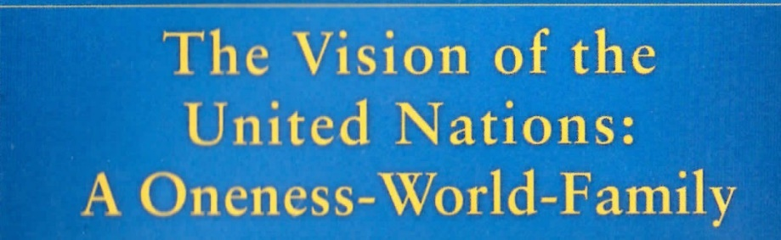
PART 3
Events and Programmes
Offered by
Sri Chinmoy: The Peace Meditation
at the United Nations
The Inner and Outer Role
of the United Nations
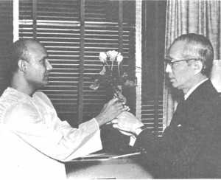 | 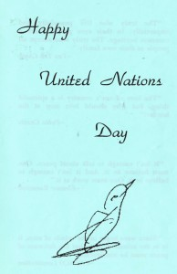 | 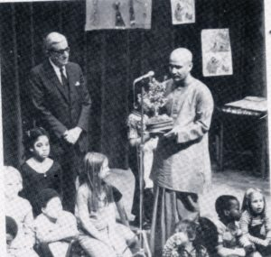 | 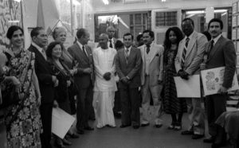
History | UN Anniversaries | UN organizations | Countries - Culture
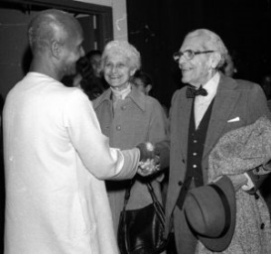 | 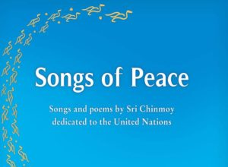 | 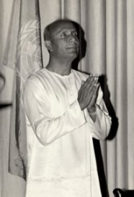 | 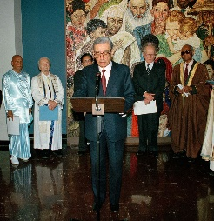
Honour Individuals | Music, Concerts | Meditation Guidance | Interfaith Harmony

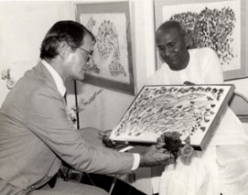 | 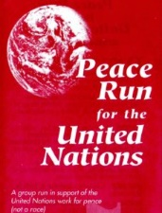 | 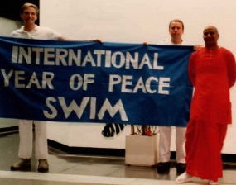 | 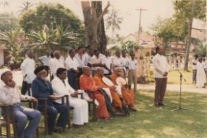
Art | Walk-Run-for UN | Sports- Athletics | Special Events
United Nations:  The Heart- Home  of the  World Body | 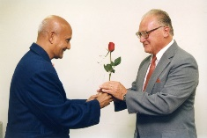 | 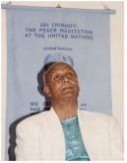 | Peace  is the  Beginning  of Love
 | Kind Words- Tributes | Build on Inspiration

