'Excerpt from the notes of Chameli Herdes, Executive Secretary of the Economic and Social Section of the US Misson to the UN —
U.S. Mission to the United Nations
799 United Nations Plaza
New York, NY 10017
(Part of the U.S. Department of State)
Sri Chinmoy asked me to Invite Harry Cahill, (U.S. Representative on the
United Nations Economic and Social Council) to the House of
Representatives building in Washington D.C. for a lifting program to lift I Congressmen. Mr. Cahill kindly accepted. At the program we were waiting goo for the guests. When Mr. Cahill arrived, I introduced him to Sri Chinmoy, and Mr. Cahill was lifted. He was then asked to make some remarks and he impressed everyone with his words of oneness and understanding. In the meantime other Congressmen came to pay respects and some to be lifted. The climax came when Congressman Gilman and Congressman Ackerman came together and Sri Chinmoy lifted both of them together. The remarks that all the Congressmen made were so extraordinary — they recognized what Sri Chinmoy was doing — and how much they appreciated him. It was heartwarming to hear. The nexrt day, Sri Chinmoy said that the day was "IMMORTAL".
Subsequently, Sri Chinmoy invited Mr. Cahill to have dinner with him at Annam Brahma in Queens. The notes on that dinner follows.
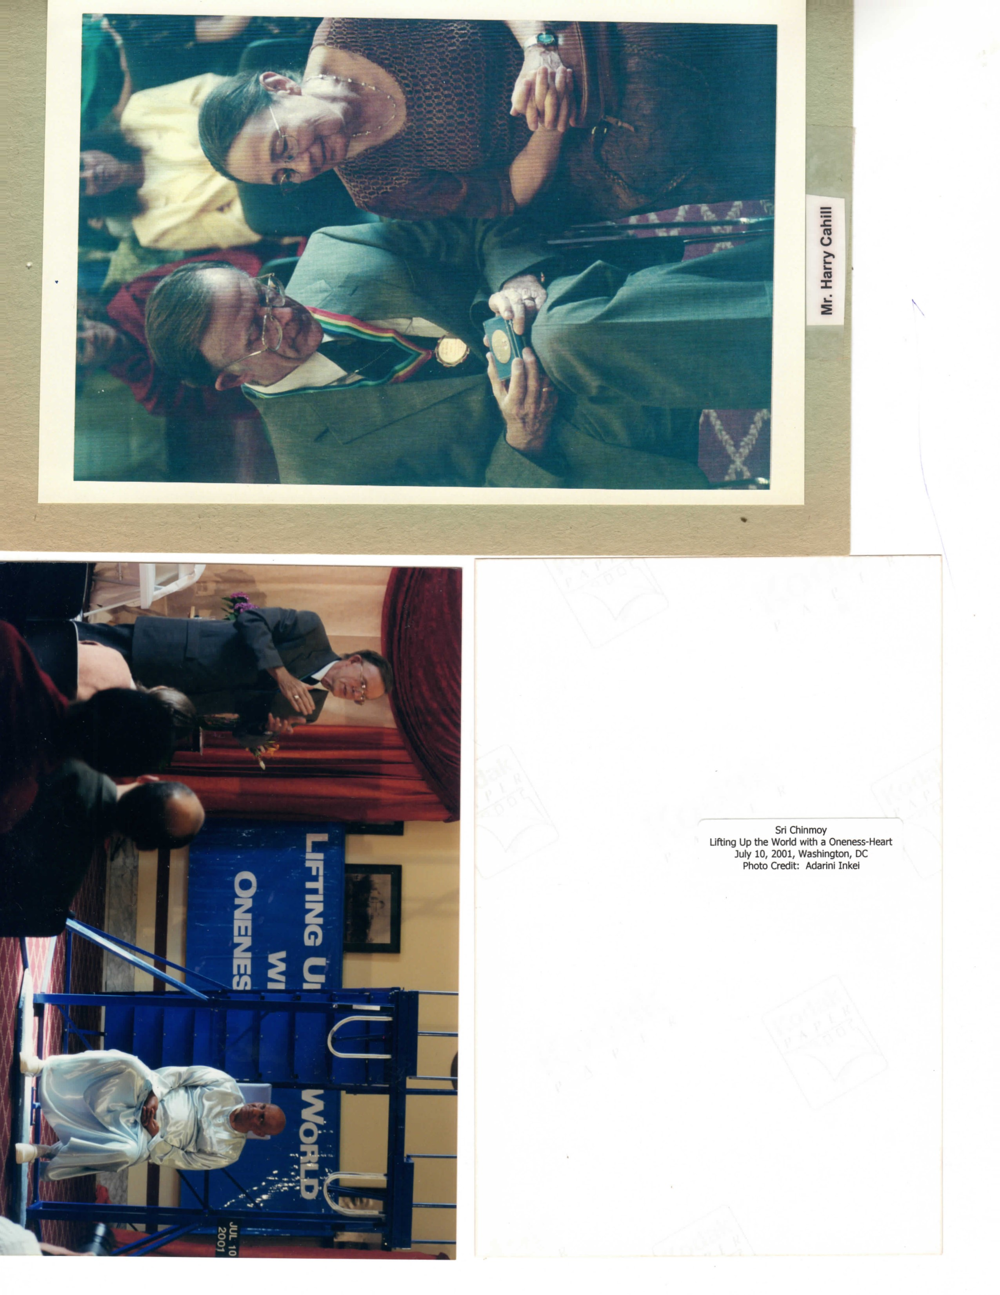
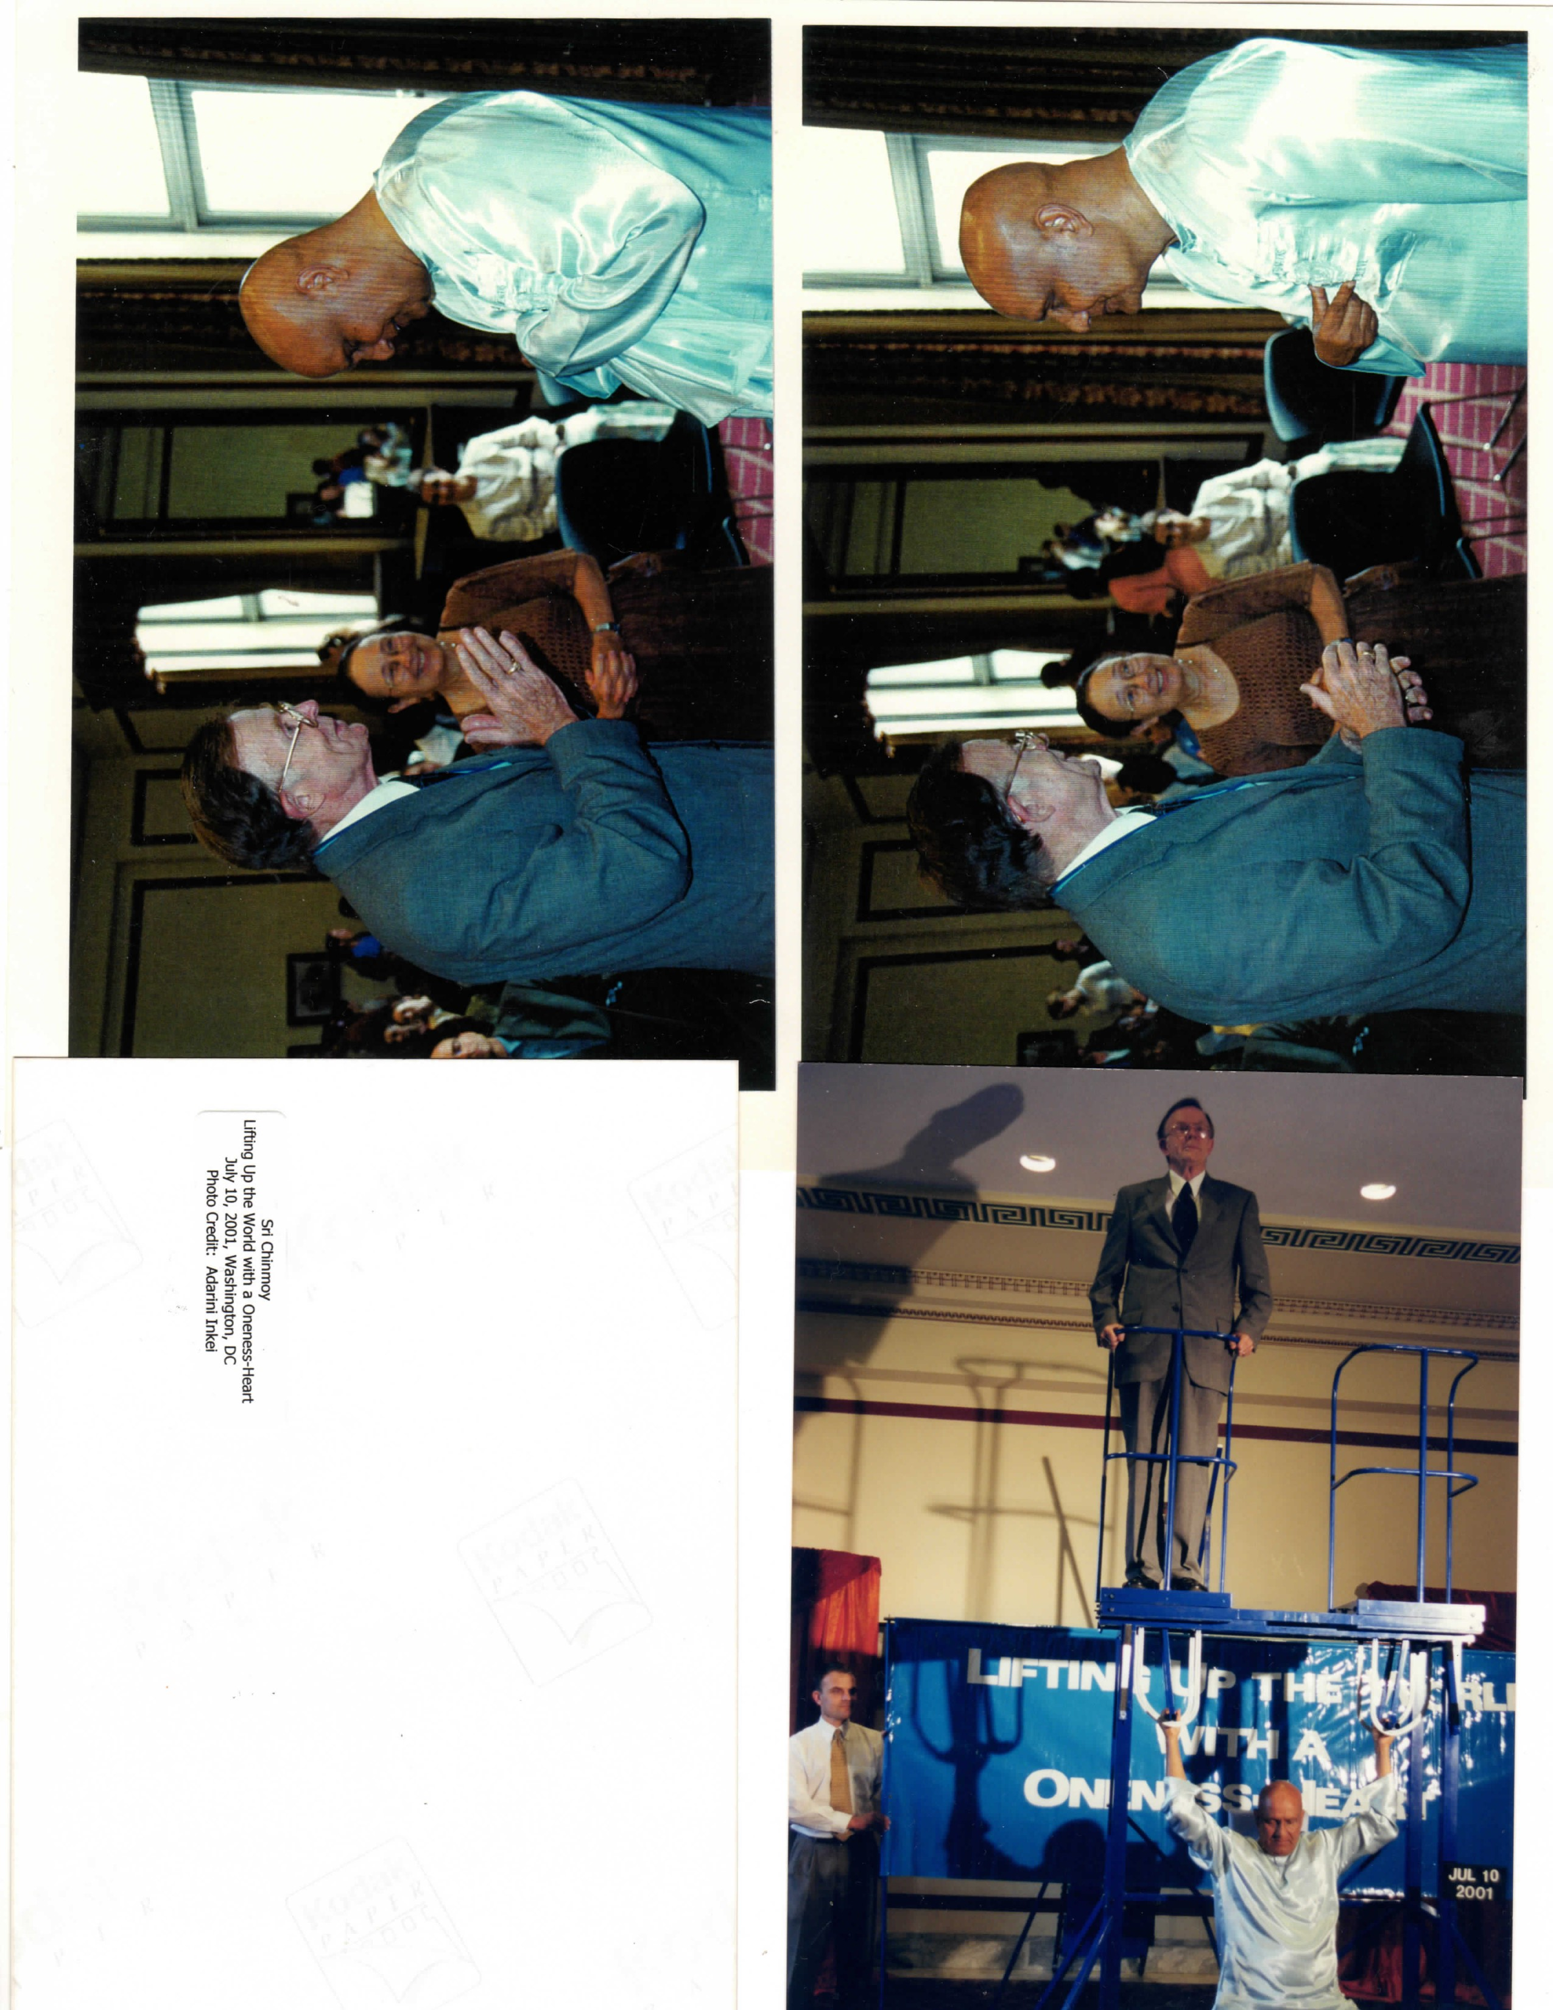
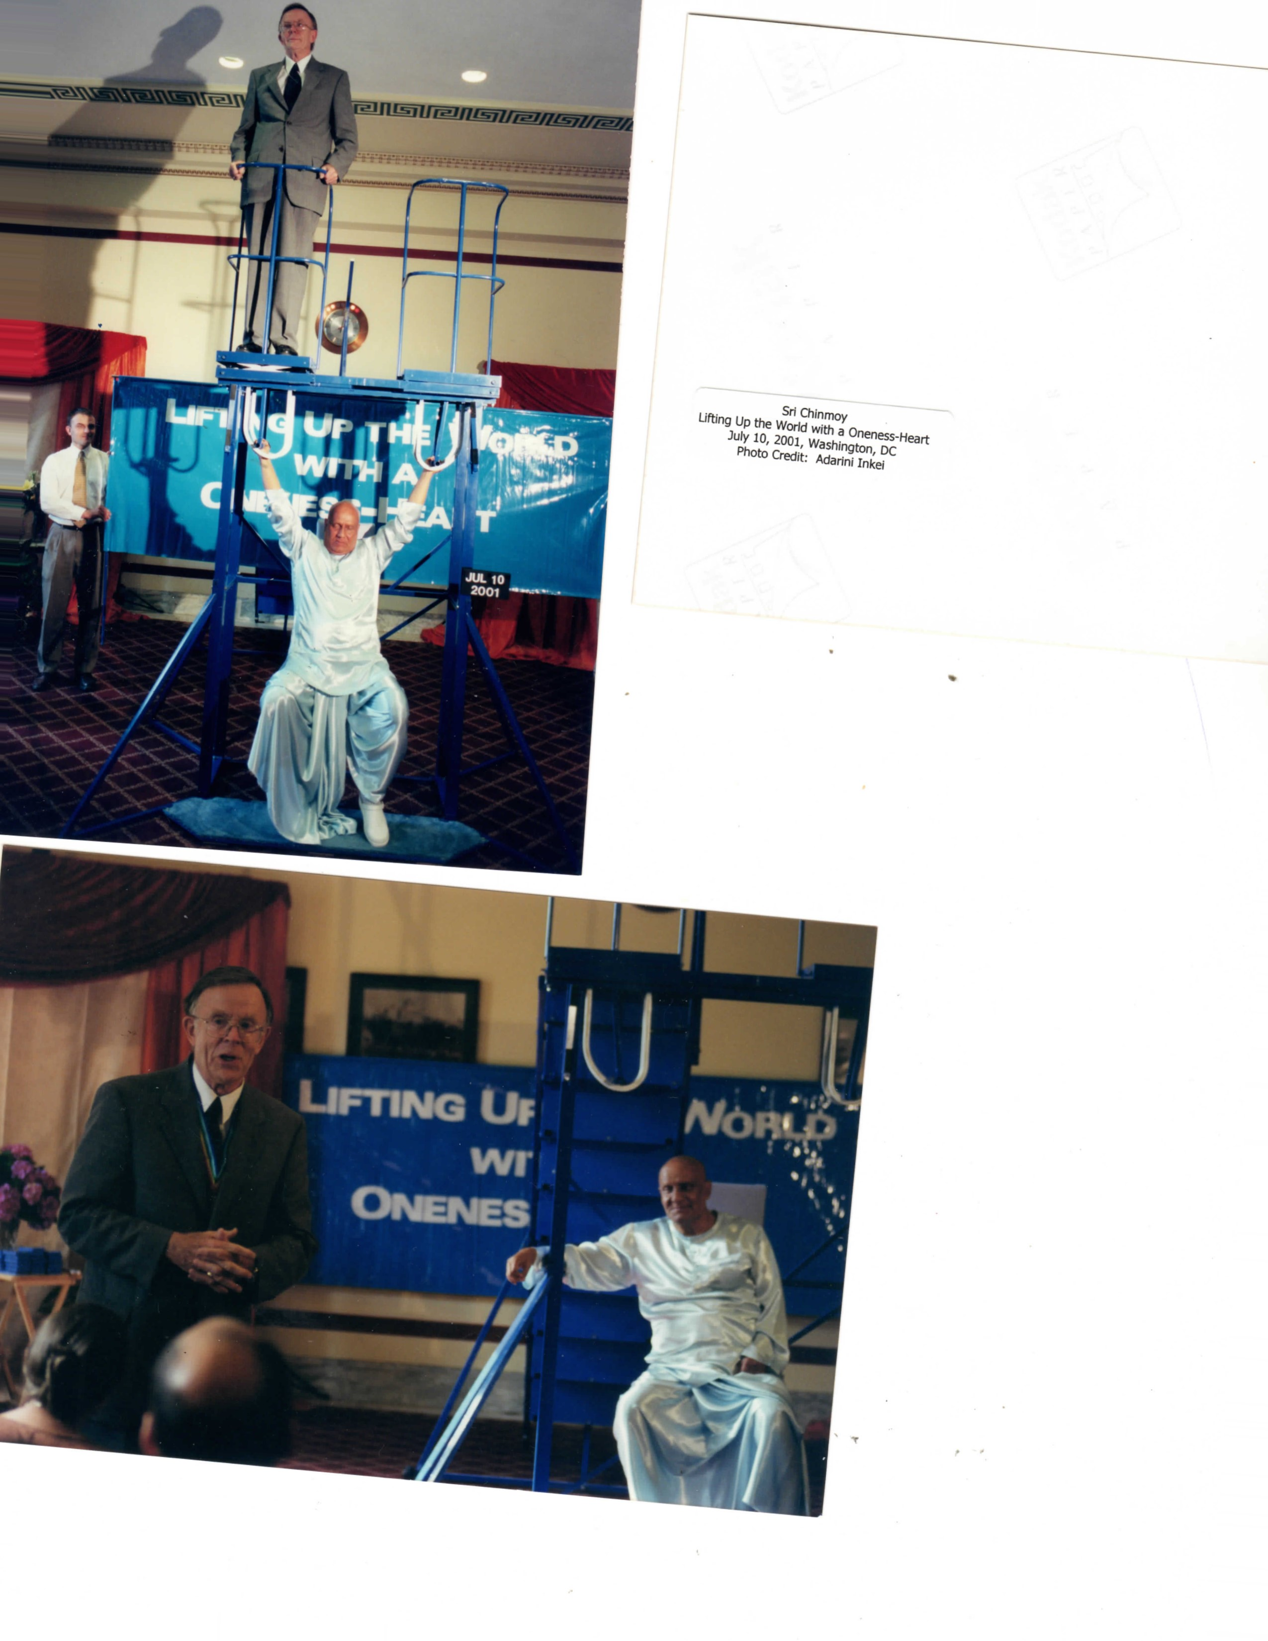

Private Dinner at Annam Brahma (Excerpt From book "Memories Chameli Herdes)
The U.S. Mission was a very interesting place to work, and I met many high-ranking diplomats, some of whom I remained friends with. It was like a small Embassy and had a family-like atmosphere. I enjoyed my work, which made good use of my organizational skills. I was head administrative secretary of the ECOSOC section, which dealt with the economic, social and humanitarian issues at the UN.
Over the years I had many bosses who were part of the Foreign Service. Most were transferred every two or three years. Even so, I had a warm relationship with many of them, and they kept in touch with me after they left the post. This included Ambassadors and Counselors in my section. In this way, I was able to introduce many high officials to Guru.
One of my bosses, who was the head of my Section, had previously been U.S. Consul-General in Bombay, India. He was very much loved by the people there. Perhaps because of that background, he had a warm feeling towards Guru. I invited him to be lifted at a function in Washington, DC, where Guru was planning to lift two Congressmen. Due to a delay in their arrival, my boss stepped up to speak and entertain the audience until they arrived. Guru was touched by his gesture. Of course, he was lifted as well.
When we got back to Queens, Guru asked me to invite this man to have dinner With him at Annam Brahma. It was only going to be a short meal, but Guru enjoyed his company so much that the dinner lasted for three hours. The restaurant was closed to customers during that time. The table was elegantly set for three, and the food was gourmet fare. The conversation was very animated, and I, who tend to be rather quiet in these circumstances, chimed in every once in a while as well. It was a wonderful evening. When we were ready to leave, I noticed many disciples had their faces pressed to the restaurant window to see what was going on.
Chameli and her boss enjoying a private dinner with Guru.
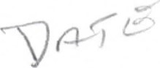
Ambassdor Jonathan Moore was United States Representative to the
United Nations Economic and Social Council from 1989 to 1992.
He and his wife met with Sri Chinmoy following a peace meditation at the United Nations.
Sri Chinmoy remarked as he was leaving the building that he was very glad to have met with the Ambassador and he was very pleased with the meeting.
