S fhser Cell l)
August 1993
Dear Brother/Sister,

This is a friendly reminder about the PEACE WALK and SEVEN
MINUTES OF WORLD PEACE. Details of both events are enclosed.
Brochures and posters for the Peace Walk like those enclosed are available.
Please see your regional coordinator or Surashri or Nilima if you have questions or need more materials.
Please contact the person indicated on the cover of this envelope by phone or fax before Wednesday, 22 September, confirming that your Peace Walk took place and giving the number of participants and any other information that you wish to convey. It is important that this information is received quickly because a report will go to Guru and to the new President of the United Nations General Assembly by Friday, 24 September.
Thank you so much!
Surashri
Enclosures:

About the events nstructions and information for Peace Walk organizers Peace Walk brochure Peace Walk poster • Songs on Peace and the United Nations for use during the Peace Walk Peace Walk 1992 results Information page on Seven Minutes of World Peace
About the Events
The Peace Walk
THE PEACE WALK takes place on Tuesday, 21 September 1993, the United Nations International Day of Peace (third Tuesday of September each year - the opening day of the United Nations General Assembly). It was Guru's idea to have Peace Walks in Centres all over the world, and to invite prominent world citizens to participate. He also suggested that participants carry flags of the United Nations or of their own country. Guru prefers the morning hours because of the peaceful atmosphere, but you may organize your Peace Walk at another time if you feel that would be better in your area. Please see the reverse for instructions and information on organizing your local Peace Walk.
Seven Minutes of World Peace
Seven Minutes of World Peace is a simultaneous global observance of silence on United Nations Day, Sunday, 24 October 1993, at 1 p.m. New York time, or 17:00 Greenwich Mean Time. Please use the enclosed information page as an original for photocopying and distributing.
(Please see reverse)
August 1993
The Peace Walk
Instructions and information for organizers
Brochures and posters are available for you to take back to your Centre. Please see your regional coordinator, Surashri or Nilima.
- The Peace Walk should take place on Tuesday, 21 September 1993, the United Nations
International Day of Peace. The morning is preferable because of the meditative atmosphere. The route could include a landmark symbolic of peace.
- You may want to print a small flyer with the details of your local Peace Walk, such as time and place, and perhaps a map, to be inserted into the brochure. Sponsors should also be included - The Sri
Chinmoy Marathon Team or Centre (your choice) in co-operation with Sri Chinmoy: The Peace Meditation at the United Nations and ... You can contact the local UN Association, local government, embassies or peace, spiritual or religious groups to be co-sponsors. (The New York Peace Walk will begin and end at the United Nations from 8-9 a.m. and is co-sponsored by ambassadors of several countries to the UN.L
- You could have a ceremony or prayer-breakfast in conjunction with the Peace Walk and invite prominent people. An interfaith theme seems to work well with this event. In New York we hold an interfaith Prayer Breakfast hosted by a UN ambassador (1993 - Argentina) after the Peace Walk, at which religious leaders from six different traditions offers prayers, and which has been quite successful.
- Please be careful that any information you distribute or anything you say to the press, etc., is worded in such a way that it does not misrepresent Guru's relationship with the United Nations. Please be familiar with the wording in the brochure that you receive from us.
- Spanish translations are available from Surashri. For other languages, please see your regional coordinator. If you translate this information, please send a copy to: The Peace Walk, 86-24 Parsons Blvd., Jamaica, New York, 1 1432.
- Guru's songs on peace and the United Nations are enclosed. Singing these songs during the Peace Walk helps create a meditative atmosphere. More copies of songs are available on request.
- If you would like to purchase flags of the United Nations or any country for the walkers to carry, we can obtain them for you at the United Nations. Please inform us how many you need. The miniature flags
(4" X 6") are $1.50 each.
- In September, please report the results of your Peace Walk promptly by calling or faxing the person indicated on the cover of this envelope by Wednesday, 22 September. Please confirm that your Peace Walk took place and give the number of participants. You may also wish to mail a detailed report including photos, press clippings, etc. to: The Peace Walk, 86-24 Parsons Blvd., Jamaica, New York, 1 1432.

PI-10& punueS3PPI-Il
696一
SUO!IVNPöl!un DNITlVdsnNI'I
g,•pua s e 9 eseYIVA
81 IZ ADVAdAHIuoddnsI•POOWOUJOJ(I
pue -LIO一一ead000IVUOIJPLI-IOJUI
110øoeødpale 03 9141dpq 014 q op uoneBII(10
sequos-10d
SUO!IPNP3J!Un JO -leapnu一0 01-11JOosneooq„
puelölluaq ON·一 一d13 ,OD926一
gumDVWNVDIdåOD(IVAdIVW
: 2u0 011esnJöJ pue
öJ!I」0:oads pue2A0:0Kunsøp
KIIWPJuewnq dpq
-13Kmdpup1111ds111一一9110Ku一0冖1„
'IL13!d130ä086一
qgAInösgzgugd0 00V
•oldoad suogepuauetu pue
o 一 0pue.1ö3unqILI-IPS!P
öId0öd01-1:0
,U00 一e」aq一一0一S! 0一 2q1 •aoead0一 ap一
IJO e'YIVAADVAd uoddns1„
P3!JJV 6一
•W(INOWSgqdOHSIqHDdV
•SSOUSSOIJIOSpue
THE
PEACE
WALK
86-24
Parsons
Blvd.
Jamaica,
New
YO
,
11452
dOIöA9p Ile2 'UO!S!A!Ppue
BU!EJJIISPIJO&pue0:a 01.11•YIVA\
ADVAdAHIU!uoned101ued 1„
SA.LVaanVPl ON
O(INa
thedawnhours,a冖ime0一daychosen havebeenco-sponsoredbyambassadors0乛 | PeaceWalkswill冖akeplaceduring dentwiceannuallysince一985·Theseevents | Around冖heglobeanumber0乛 UnitedNa冖ionsdelega冖esands 乛乛have participatedinPeaceWalksin冖heLl.N.Gar- | ance0乛spiri冖ual冖eacherSriChinmoy. | walkersworldwide. 乛orworldpeacesince一970undertheguid- | manyfai冖hswillbeamong冖he smedi冖a乛乛who冖a冖ions,havespecialbeenprogrammesholdingtwice-weeklyandevents | musiciansandreligiousleadersOf 「OLIPisanassocia冖ion0乛uN.delega冖esand | publicservan冖s,sportspersonali冖ies· tationattheUnitedNations."Thismeditation
spiri冖ualquali冖ies. | 冖hegrea冖estimportance冖0spiritualvalues, | havecertainprioritiesinregardstovirtues andhumanvalues...aboveall,一wouldat冖ach | wasa一一乛e一on practitioner0乛medi冖ation:··一 | 乛orwha冖youaredoing乛0「mankind."IlThan冖 | tions,in一972·IlThantsaid,"Pleasefeel mysincererespectandsincereconcern | Secre冖aryGeneral0乛theUnitedNa- | ThePeaceWalk,metwithuThant,third
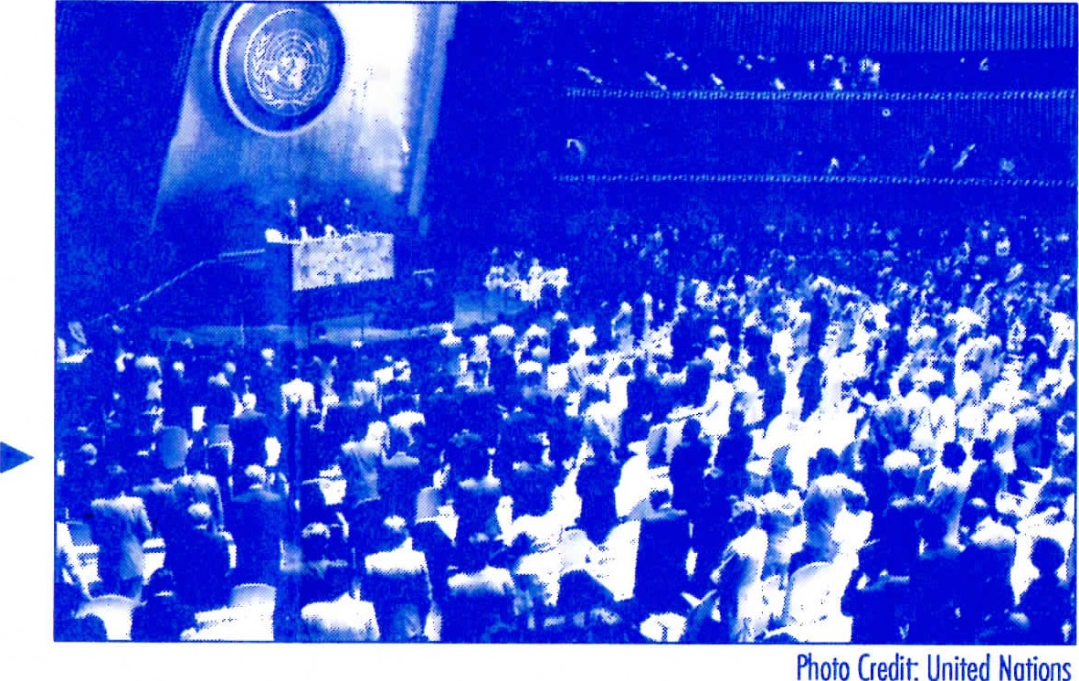
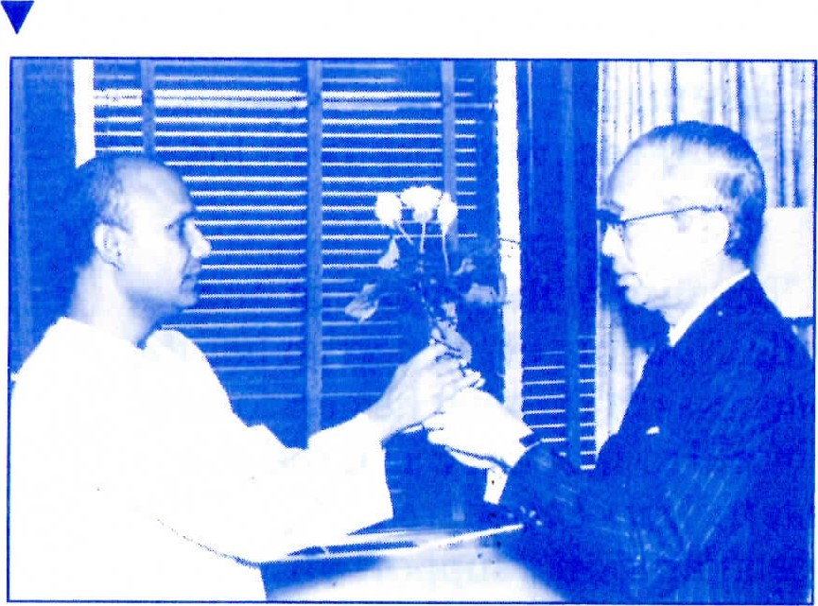
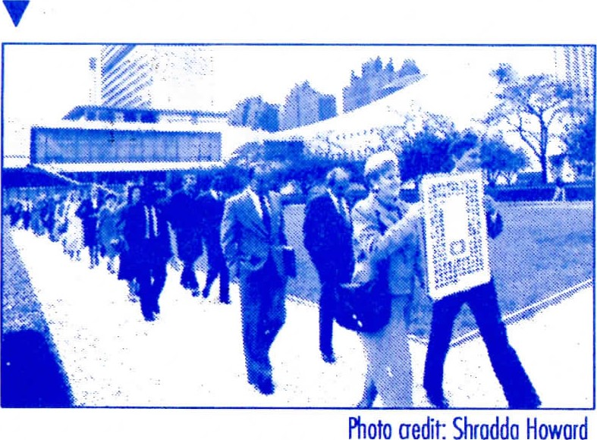
AMINUTEOFSILENTMEDITATION WHATIsTHEPEACE beginseachyear'SsessionOf
WALK? on冖heIn冖erna-Assembly
tionalDay0乛Peace,冖he冖hird
Tuesdayo乛September.On冖ha冖same
day,around冖heworld,participan冖s
1 nTuesday、2一September一995 乛ul乛ortheu冖supportprogressmost
,theUNITEDNATIONS oftheGeneralAssemblytowarda lastingworldpeace. 一 INTERNATIONALDAYOFPEACE,
peopleindozensOfCi冖iesonseveral con冖inen冖swillwalk乛orpeaceina
con冖empla冖ivespirit.Walkerswill
carry冖heflagsOftheirownna冖ions
THEPEACEWALK,HELDINCITIESAROUNDTHE
orOftheUnitedNations.ProminentworldontheIn冖ernationalDay0乛 worldci冖izens,includingdiplomats,Peaceeachyear,iscoordinatedworld-
wideby"SriChinmoy:ThePeaceMedi- SPIPITUALLEADERSQICHINMOY,INSPIQEPOF
manyU.N.MemberNationsalongwith"Sri 乛or一冖scalm,medita冖ivequali冖ies·In Chinmoy:ThePeaceMedita冖ionattheuni冖ed NewYork,par冖icipan冖swillwalka Nations."ThesincereinterestOftheinternarou冖ebeginningandendinga冖冖he tionaltothecommunitycrea冖ionOftheon冖heseworldwideoccasionsevent:hasTheled UnitedNations. PeaceWalk.
ThePeaceWalkisanannualevent inauguratedin一986inhonourOf冖he InternationalYearOfPeace.Itisan
oppor冖uni冖y乛orpeople0乛allna冖ions, culturesandreligions冖0concentrate onthequali冖ieswi冖hin冖hehuman
spiri冖whichform冖hefounda冖ion
uponwhichlas冖ingpeacecanbebuilt.This一0乛0乛m00is乛0彐 0-:0冖0 8一00冖 乛ily
乛乛0 一 Offi 一 0一theU.N.or A000冖 ,

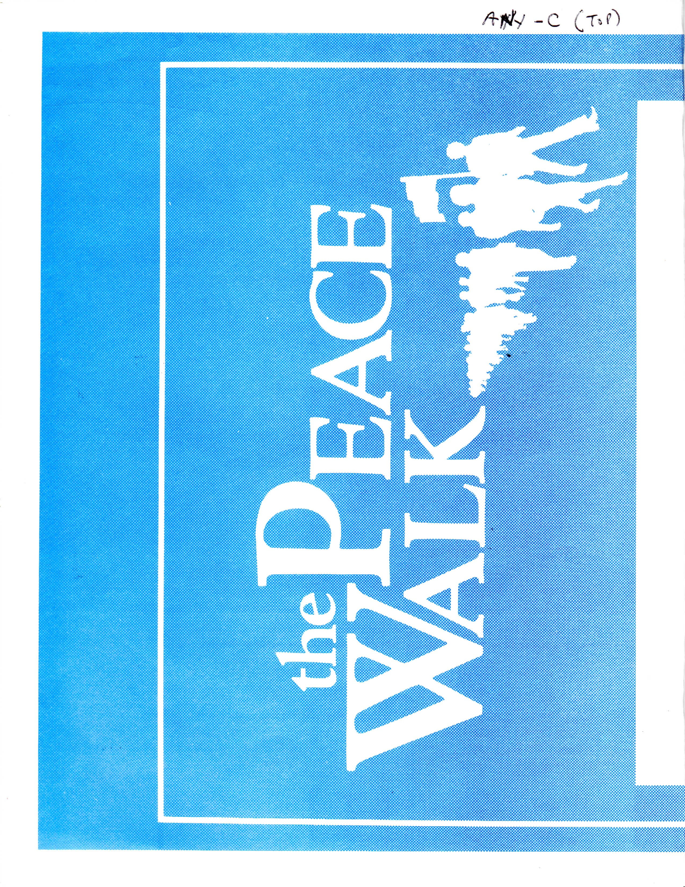

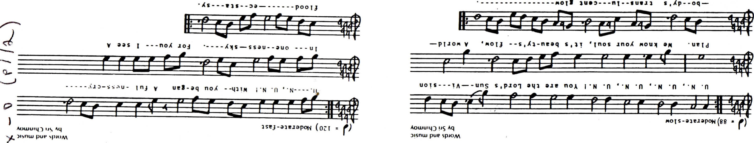
2

NくD39 っOA 工1一 NVId NOISIA-N()S SICI 01 3工1
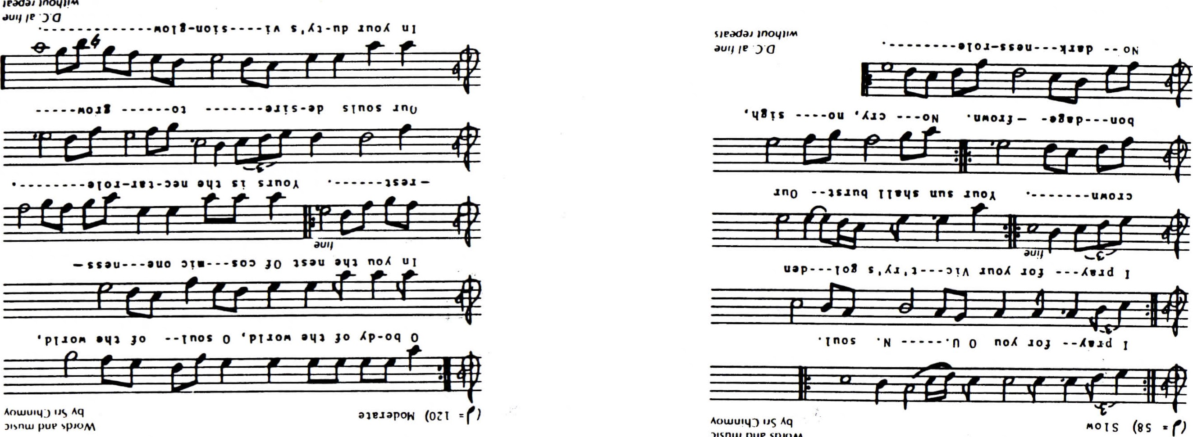
)
-
の
コ
(
に
pue
5
て
」
0
、
M
01 0 3エト 亠0 A009 0 っOA 0」 ÅVYd 一

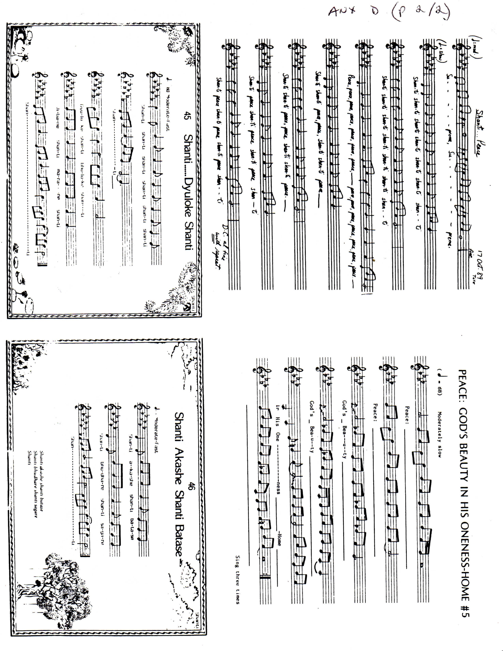
The World-wide Event
Peace Walks took place on 15 September 1992
Argentina | Montpellier
Buenos Aires  Australia | Nancy  Paris
Adelaide | Germany
Melbourne | Berlin Münich
Austria  Salzburg | Nürnberg
Vienna  Belarus | Hungary  Budapest
Minsk  Croatia | India  Hyderabad
Zagreb  Canada | Italy  Milano
Edmonton | Japan
Halifax  Montreal | Tokyo
Ottawa | Russia
Quebec | Moscow
Vancouver | Smolensk
Victoria | St. Petersburg
Finland | sierra Leone
Helsinki  Vaasa | Freetown  Slovenia
France | Lj ubljana

in over 50 cities:
Sweden
Stockholm Uppsala
United Kingdom
Cambridge Ipswich
USA
Boston Carrboro, North Carolina
Cincinnati
Los Angeles
Miami
New York
Portland, Oregon
Providence
Tampa Bay, Florida
Washington DC
Woodstock, Vermont
Yugoslavia
Belgrade
Nis
Novi Sad
Z imbabwe
Harare Murewa
Mutare

Amiens

S E V E N M I N U T E S O F WO R LD P E A C E
86-24 PARSONS BOULEVARD, JAMAICA, NEW YORK 1 1432, U.S.A.
"The outer message of the United Nations is peace.
The inner message of the United Nations is love.
The inmost message of the United Nations is oneness. "
— Sri Chinmoy

SEVEN MINUTES OF WORLD PEACE - A SIMULTANEOUS GLOBAL OBSERVANCE
On United Nations Day, Sunday, 24 October 1993, individuals, groups and organizations around the world will simultaneously join in seven minutes of silent prayer or meditation to share the spirit of peace on earth. This observance, initiated in 1984, iB called SEVEN MINUTES OF WORLD PEACE. Around the globe, local observances will be held at times corresponding to 1.00 — 1.07 p.m. Eastern Daylight Time at United Nations Headquarters in New York (17.00 — 17.07 Greenwich Mean Time) .

HOW TO PARTICIPATE
By individually or collectively observing silence to pray or meditate for peace during the local time in your time zone which corresponds to 17.00 — 17.07 Greenwich Mean Time on Sunday, 24 October 1993 — United Nations Day. Those who wish to organize a group observance may do so by informing members of their organization, their comrnunity or the public of the local time and place of the observance. The text of this announcement may be used, either in part or in its entirety, to create information circulars or articles publicizing the local Seven Minutes observance;
By notifying us of your participation immediately after the observance so that we may know the total number of participants, both individual and group (submitted by the group organizer) . Please write to: SEVEN MINUTES OF WORLD PEACE, 86-24 PARSONS
BOULEVARD, JAMAICA, NEW YORK 11432, USA. You are also invited to write a letter and/or send photog, posters, programmes or news articles.

ITS PURPOSE
SEVEN MINUTES OF WORLD PEACE seeks to focus the world's attention on the urgent need for peace in the international and inter—religious spirit of the United Nations. The observance offers people of every country and belief an opportunity to transcend their individual and national identities and join all humanity, even if for just a short time, in the spirit of peace as part of the human family. SEVEN MINUTES OF WORLD PEACE has no political affiliation or purpose other than to work toward and strengthen the universal human aspiration for harmony, peace and oneness among nations and peoples.

THE SPONSOR
SEVEN MINUTES OF WORLD PEACE was initiated by Sri Chinmoy: The Peace Meditation at the United Nations in co—operation with United Nations Associations in many countries and a wide range of educational, religious and peace organizations around the world. The Peace Meditation at the United Nations is an association of United Nations delegates, staff and others accredited to the United Nations, who believe that inner peace serves as the foundation for outer peace, and who actively work to pursue this goal through the United Nations. Toward this end, the Peace Meditation group has been holding twice—weekly meditations and a wide array of programmes and events at the United Nations since 1970 under the leadership of meditation teacher Sri Chinmoy.

PAST OBSERVANCES
SEVEN MINUTES OF WORLD PEACE was inaugurated in 1984 with the participation of groups in over 40 countries. The observance has since continued to spread, and can now be said to have a life of its own. Ceremonies and observances have been held around the world, and messages of support have been received from heads of State of several countries, as well as mayors, governors and members of Congress in the United States. One of the most inspiring examples of participation was organized by the United Nations Association of Sri Lanka, where over 70, 000 people joined the Seven Minutes observance in 1986, and millions in subsequent years. In the U.S.A., congressional staff, public and private schools, libraries and local chapters of Peace Links and Church Women United, as well as Unitarian and Catholic Churches, have documented their participation.

一
NO
一
ト
N
山
ト
ト
く

