ENDORSED BY

NOBEL PEACE LAUREATES
"I encourge participation in THE PEACE WALK. In order to end world suffering and division, we all must develop the inner qualities of brotherhood
and selflessness. "
ARCHBISHOP DESMOND M. TuTu
1984 Recipient, South Africa
"1 support THE PEACE WALK. a worldwide activity which contributes to peace.
The path to peace is to liberate the consciences of the people. We have to disarm hunger and create new, more just and humane relations between people."
ADOLFO PÉQEZ ESQUIVEL
1980 Recipient, Argentina
"I join you all in spirit and prayer that every step on your walk for peace will help bring the human family nearer its true destiny of love and respect for life and a refusal to kill one another." MAIQEAD CORRIGAN MAGUIRE
1976 Co-recipient, Northern Ireland
"Because of the danger of nuclear destruction, every person has the obligation to do what he can to help the world to move towards the goal of international cooperation, peace and brotherhood. I support THE PEACE WALK as a step towards this end."
DR. LINus PAULING
1962 Recipient, United States
Walk for the progress of the United Nations in its journey toward peace on earth.
Tuesday, 17 September 1991
The United Nations
International Day of Peace
In cities around the world

WHAT Is THE PEACE WALK?
On Tuesday. 17 September 1991 - the UNITED NATIONS INTERNATIONAL DAY OF PEACE people in dozens of cities on six continents will walk for peace in a contemplative spirit. Walkers will carry the flags of their own nations or of the United Nations. Prominent world citizens. including diplomats. public servants, sports personalities, musicians and religious leaders of many faiths will be among the walkers worldwide.
Around the globe a number of Peace Walks will take place during the dawn hours, a time of day chosen for its
calm. meditative qualities. In New York, participants will walk a route beginning and ending at the United Nations.
The Peace Walk is an annual event inaugurated in 1986 in honour of the International Year of Peace. It is an opportunity for people of all nations. cultures and religions to concentrate on the qualities within the human spirit which form the foundation upon which lasting peace can be built.
A MINUTE OF SILENT MEDITATION begins each annual session of the United Nations General Assembly on the International Day of Peace - the third Tuesday of September. On that same day, around the world, participants in The Peace Walk offer their prayerful support for the utmost progress of the General Assembly toward a lasting world peace.
IN THE SAME SPIRIT, UNITED NATIONS delegates and staff have participated in Peace Walks in the U.N. Garden twice annually since 1983. These events have been sponsored jointly by ambassadors of many U.N. Member Nations along with "Sri Chinmoy: The Peace Meditation at the United Nations. " The sincere interest of the international community on these occasions has led to the creation of a worldwide event: The Peace Walk.
The Peace Walk, held in cities around the world on the International Day of Peace each year, is coordinated worldwide by "Sri Chinmoy: The Peace Meditation at the United Nations." This meditation group is an association of U.N. delegates and staff who have been holding twice-weekly meditations, special programmes and events for world peace since 1970 under the guidance of spirituaL teacher Sri Chinmoy.
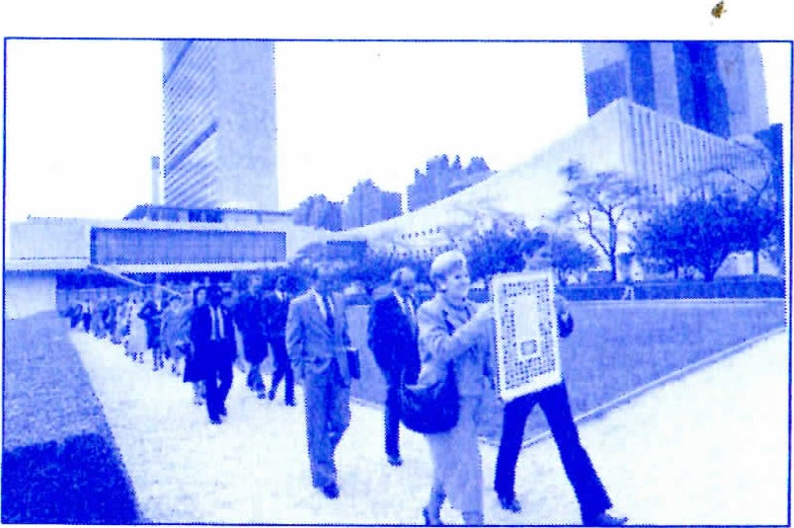
Photo credit: Shroddo Howard
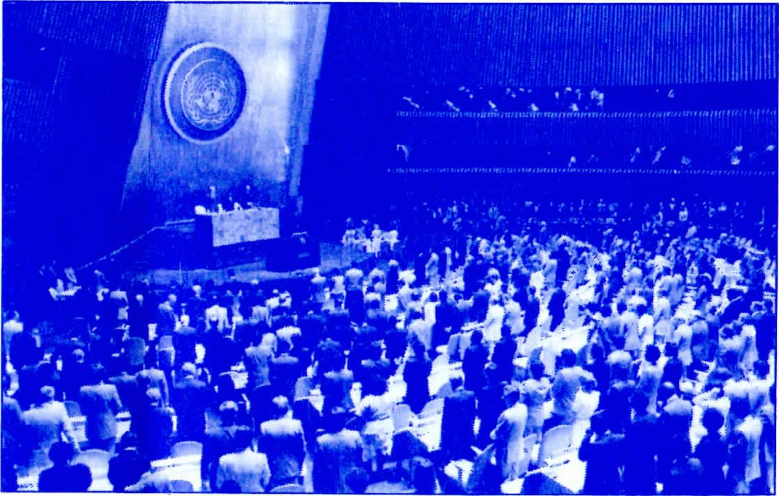
Photo Credit United Notions
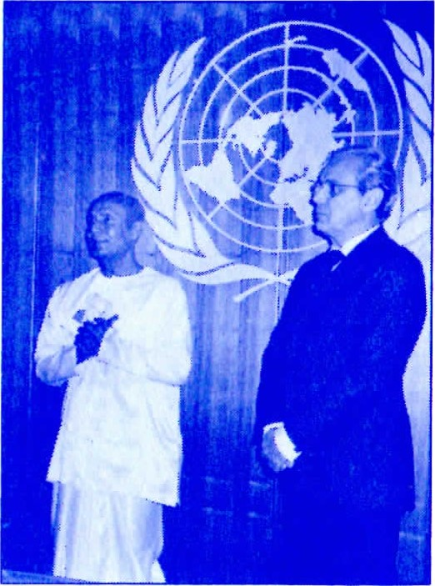
SPIRITUAL LEADER SRI CHINMOY, INSPIRER OF The Peace Walk, meditates with United Nations Secretary-General Javier Pérez de Cuéllar, who said of the work of the Peace Meditation group, "You concentrate on the truths, the ideals which unite all mankind: the longing for peace. the need for compassion ..1n recalling the fundamental
goals which inspire our work, you are helping to reaffirm our commitment to the Organization and its purpose."
Photo Credit: Romaniyo Zeoley
This information is presented as a service and does not necessarily represent the official views of the U.N. or its Agencies.

