**Peace Walk for UN Charter Day 25-26 June 1984**

**Draft under construction** – for edit consolidation and links to related

|  |  |
| --- | --- |
|  | |
|  | **TOTALS**:  275 participants representing 80 countries  17 Co-sponsors (including Samoa)  10 Permanent Representatives attended, 6 co-sponsored but did not attend  8 Deputy Permanent Representatives attended  6 Charge d’Affairs attended other than DPRs  1 Charge co-sponsored but did not attend |

**From UN Secretariat news: 16 aug 2019**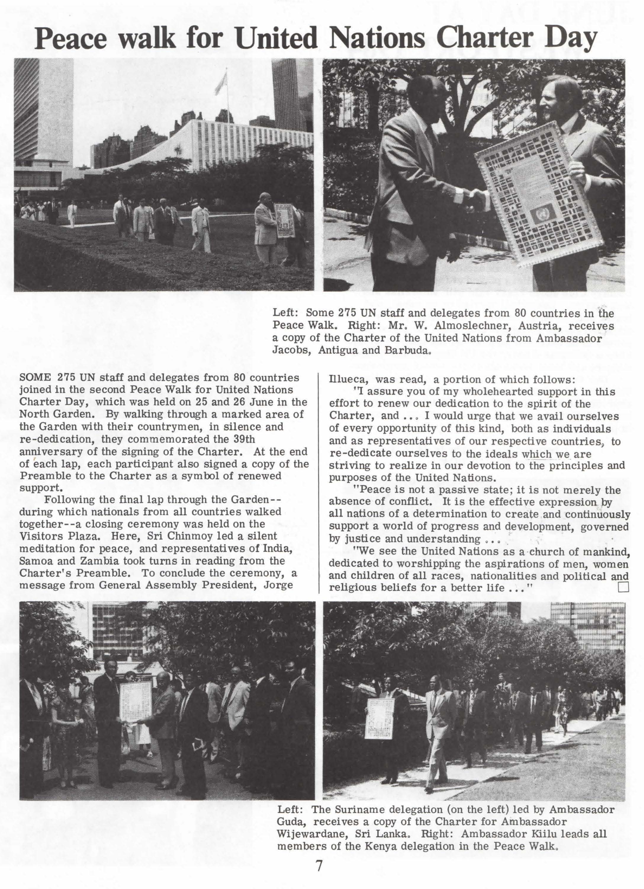

|  |  |
| --- | --- |
|  |  |
|  |  |
|  |  |

|  |  |
| --- | --- |
|  |  |

|  |  |  |
| --- | --- | --- |
|  |  |  |
|  |  |  |

|  |  |  |
| --- | --- | --- |
| 1984-06-25 -03-ckg-walks-sunil-chidananda-crp |  | |
| Pres release right after final event 26 Jun (>>v) |  | |
|  |  | |
|  | |  |

See more detail and photos at: https://www.srichinmoypeacemeditationatun.org/1984/06/26/1984-peace-walk-for-un-charter-day-june-25-26/

|  |  |
| --- | --- |
|  |  |
|  |  |
|  |  |

This **June 1984 Charter day**

See **Separate Gallery(s)**

for mention of “Seven” minutes or “7 min” in file image title**: after Oct 24 1984, which only began then.**

|  |  |  |  |
| --- | --- | --- | --- |
|  |  |  |  |