Meditation Conference “Inner Flames at the United Nations” Opening of 31st GA ; 20 Sept 1976
In order to bring into sharper focus the living reality of the U.N. and
in conjunction with the 51st anniversary of the UN and
the opening of the 31st General Assembly
the following day, the Peace Meditation Group at the UN held its second annual International Conference
on September 20 in Conference Room 3.
The all-day meeting, entitled
“Inner Flames at the United Nations,”
explored the role of meditation and spirituality in U.N. affairs.
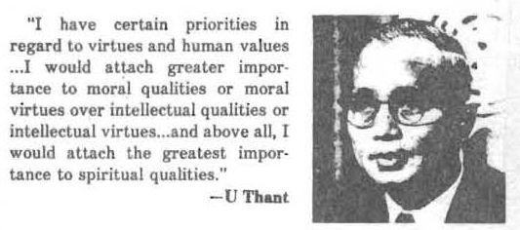
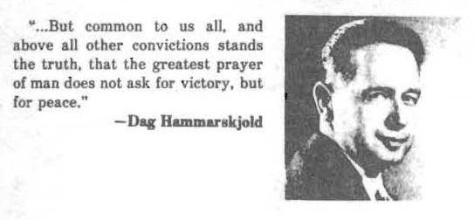
The Conference took an unusual approach in that its morning session was devoted to an inner search through meditation for the present day needs and responsibilities of the U.N.
Sri Chinmoy, Leader of the Meditation Group at the U.N., opened the morning session, which consisted of silent meditation, performances of classical music and seven songs about the United Nations which were composed by Sri Chinmoy. The session closed with his talk .
The afternoon programme included speakers:
- Barbara De Long of HABITAT;
- Joseph Eger, Leader of the U.N. Symphony;
- Donald Keys of the World Federalists;
- Louis Longarzo of Caritas Internationalis;
- Curtis Roosevelt of the U. N. Department of Economic and Social Affairs and
- William Simmons, Chairman of the Mystic’s Roundtable Group at the U.N.
Excerpts of these talks as well as statements from the United States Mission to the U.N. and the Permanent Observer of the Holy appear below.
See also Previous years programme.: Commemoration Opening 30th Session UN General Assembly 12 Sep 1975 – Interfaith

SRI CHINMOY; Leader, The Peace Meditation at the United Nations
Inner Flames at the United Nations
Inner Flames signify aspiration. Aspiration illumines the undivine in us and fulfils the divine in us. Our doubting mind is the undivine in us. Our loving heart is the divine in us. The doubting mind unconsciously and consciously tries to destroy the whole world. The loving heart consciously and unreservedly creates a new world: a world of hope, a world of light, a world of delight.
Aspiration is the inner cry. Both God and man have this inner cry. With His inner Cry, God claims us. With our inner cry, we follow God. God’s inner Cry is for our perfection and our outer cry is for God’s satisfaction.
We, the members of the United Nations Meditation Group, are each inner flames, and we are each trying with utmost humility and sincerity to be of service to each member of the United Nations, to the dream of the United Nations, to the pristine purity of the United Nations. Our capacity is very limited, but our willingness, our eagerness to be of service to each member, to each ideal of the United Nations, is sincere. And this sincerity will one day be proved and marked. Here at the United Nations, all are inner flames. No matter what an individual’s post is, whether he holds the highest post or the lowest, he is undoubtedly an inner flame, for his is the cry which is genuine. Each individual server of the United Nations, irrespective of his nationality or religious and cultural background, is undoubtedly an inner flame. And each flame serves the community of nations according to its capacity and according to its receptivity.
The original and pioneer flame was President Wilson. His dream of the League of Nations has blossomed into the United Nations. Once it was a tiny plant, but now it has grown into a huge banyan tree. It was the plant that embodied the inner flame and now, as a huge banyan tree, it has countless flames.
God and Truth are one and inseparable. Truth and Light are also one and inseparable. Truth, when it starts manifesting itself, takes the form of Light and this Light illumines and fulfils the seeker in us.
The seeker in us always wants to satisfy the little world and the big world. The world that we claim at the beginning of our life-our home, our parents, our brothers and sisters, our relatives-is the little world. But as our vision increases, as we look around and see a bigger world, an unhorizoned world awaiting us, at that time we claim the big world as our very own.
Each individual who has come to serve the United Nations represents his own country, his small world. But when he becomes part and parcel of the United Nations, the big world, at that time he is for all, for the entire humanity. He started his journey with his own country and then he arrived at the goal of goals: universal oneness.
The United Nations wants to solve all the world problems. It is more than eager to solve all the problems that the world could ever imagine. In various ways it is trying to solve the world’s problems lovingly, devotedly, soulfully and unreservedly. A problem indicates confusion, a problem indicates the dance of ego, a problem indicates human weakness. Each problem can be solved and will be solved by only one thing and that is the message of union. This union comes to the fore only when we kindle the inner flame. We, as seekers, know perfectly well that it is the inner flames that are burning inside all the members of the United Nations that are inspiring the members to solve all the problems of the world.
Today’s meeting is honouring the General Assembly. At the General Assembly each individual nation comes to offer its light, truth, willingness-capacity and sense of oneness. Each country embodies truth and light in its own way. But each country feels and knows in the inmost recesses of its heart that the light and truth it embodies cannot be sufficient. Therefore, it tries to accept and receive light from other countries. Similarly, each flame that each individual embodies cannot be sufficient to solve any world problem or to illumine world-ignorance. What is needed is the unification of all the flames that are here, there and everywhere. So all the flames that are here have to be collected so that they can muster their joint strength. At that time, the ignorance-dream that separates one country from another, one man from another, can no longer last. It will be replaced by Wisdom-Reality. And what is Wisdom-Reality? Wisdom-Reality is the song of oneness. This song of oneness is founded only on self-giving, which is nothing short of truth-becoming. And truth-becoming is oneness with the all-embracing, all-loving, all-illumining and all-fulfilling Reality.
The higher reality is the soul in us; the lower reality is the body-consciousness, which we are right now. The lower reality aspires to grow into the higher reality. The higher reality inspires us. A great many individuals think only of the lower reality, the body-reality, as the United Nations building, where thousands of human beings are serving the one cause. The building-reality, the body-reality, of the United Nations immediately captures their minds. The outside world does not easily think of the soul-reality, which is the real reality of the United Nations. But it is the loving souls, the illumining souls of the United Nations that guide the body-reality, or try to guide it. The day will come when the outer world will realise that looming large inside the body-reality is the soul-reality.
We the seekers and members of the United Nations Meditation Group are trying to serve both the soul-reality and the body-reality according to our very limited capacity. Our capacity is very, very limited, but our sincere efforts we place at the Feet of the Inner Pilot of the United Nations. This Inner Pilot is our fate-maker, the Author of all Good, God. It is the Creator in God and the creation-fruit that is all light and life and perfection.
20 September 1976 , appears in The Seeker’s Mind, Agni Press, 1978

MS. BARBARA DeLONG Member, HABITAT Secretariat:
As you know, HABITAT: United Nations Conference on Human Settlements, was one of a series of large inter-governmental conferences on major problems facing our society which have been held in the past few years by the United Nations for improving the quality of life.
HABITAT was held m Vancouver, B.C., Canada at the end of May this year. At that time, 11 representatives of nearly all the Member States of the United Nations met together to discuss the problems of where and how people live in villages, towns and cities in every climate and culture, in all nations of our present world. I was fortunate enough to attend the Conference as a part of the HABITAT Secretariat.
During the Conference, I was aware that the consideration of the crisis that the world is now facing in human settlements naturally encompasses both the physical and spiritual needs of the world’s people. For these two aspects of human existence can never be separated. Without a secure and livable environment, we will never be free to enter into the search for a deeper, spiritual knowledge of our lives; and, at the same time, by our aspiration, prayers and meditation, we actually create the forces of peace, beauty, harmony and love for one another which alone can permanently correct the harsh and often unpleasant realities that we face in our present environment.
The first goal or objective of the Conference was: “To proclaim and ask all nations to subscribe to a commitment pledging that the future human settlements of the world will be places of human dignity and well-being.” Tacitly understood in this statement is the fact that in our attempts to practically correct, rebuild and remodel our human settlements, the spiritual values and needs of men and women must also be considered, honoured and protected.
We commemorate today the opening of the 31st General Assembly. Another major goal of the HABITAT Conference, that of approving a proposal of institutional arrangement for international co-operation in the field of human settlements, will be considered and decided upon by this General Assembly. We are reaffirming here our belief in the ideals of the United Nations and rededicating ourselves to these goals. Not only as a representative of the HABITAT Secretariat, but personally as a member of this United Nations Organization and of our human family, I sincerely hope that this Conference will indeed inspire a spiritual awareness in the consideration of this important human settlements question and the other important issues that will be taken up at this session of the General Assembly.

MR. JOSEPH EGER, Leader, Symphony for the United Nations
Good afternoon. I hesitate to break the beautiful silence. The only thing that I value as much as silence – and maybe it is the same thing – is music ; because just as silence is a common denominator, so is music. We of the Symphony for the United Nations are a group of people dedicated to the idea that it might be worthwhile to explore and harness the power and the emotion of music to improve communications among peoples. It may be a very modest purpose, or it may be a very ambitious purpose.
We define music differently than some cultures do and one of the reasons I’m happy to be here is because of that redefinition. In some cultures represented here in the United Nations, the word for sound is “God.” God is music. Quite a few hundred millions of people on this earth believe that and use words in this way. In many other cultures, including our Western culture, we often deify musicians. I venture to say that some of the pop stars or the rock stars or musician stars have a larger constituency than, perhaps, most of the politicians whether they be in government or out. For music seems to cross so many barriers. We of the Symphony for the United Nations are trying to utilise music to cross barriers, just as the United Nations itself provides a forum for people to come together and communicate verbally rather than communicate’ by fast-traveling missiles called bullets and bombs and such.
Another reason I’m happy to be he re is because I’ve been studying, among other philosophers, the works of Sri Aurobindo -a man who, I understand, Sri Chinmoy also studied considerably more than I. I’m fascinated by Sri Aurobindo’s teachings because they so parallel my own life’s conflicts. On the one hand, I do believe, with all my heart, that we are one, that aH humankind is basically one. We’re united. On the other hand, I do believe with all my heart, that in this very real world there are forces which are unbelievably destructive and hurtful and exploitative. Sri Aurobindo, who was a great saint, didn’t climb to the top of a mountain and meditate there all his life. In fact, he spent a lot of time in jail because he believed that India should be free and he believed in the pursuit of truth. So evidently he has this conflict as well, but maybe it’s not a conflict after all. Maybe it’s the same thing. Maybe the pursuit of truth and the fight against untruth are part of the same oneness. And perhaps, I don’t know if I sound clear to you – it’s a little unclear to me still- but perhaps in pursuing truth we can find a deeper oneness. And perhaps this is the better way to fight untruth, pollution, corruption, war, destruction, sickness, mind pollution and all these things that we talk about as being evil. Perhaps these forces can be drawn toward truth. In any case, that seems to be what I’m dedicating myself to and our organisation seems to be dedicating itself too
We are not formaly connected with the United Nations, although we have a number of your top officials who are on our board and committee. We are an independent organisation, dedicated to the same ideals and aims of the United Nations, like U.N. We Believe or the United Nations Association. And we are a new organisation; we made our debut last October on United Nations Week. We have now representations from all over the world – some of the top artists and musicians from the Communist world, the Middle East, the Far East and the Western World. We are planning international festivals, workshop forums, concerts and the use of all music – not only one kind of music, but all music from all cultures – to improve relations and communications. Hopefully we’ll be a tiny step toward a world of peace.
So I’m glad to be here today and I’m glad to share the quiet and the peace of this room. 1 hesitate to use the word “pray” because 1 was a lifelong atheist until I realised how religious I really am. But I do pray that we can spread the awareness and that’s all it is-of what already exists. And that is the flame in all humankind, the divinity , if you will, in all humankind.
Thank you.

MR. DONALD KEYS World Association 01 World Federalists
Thank you. Here we are on the eve of the 31st session of the United Nations General Assembly, which will mark a few more small steps in the edging forward of the human community in manifesting and actualising the values, goals and ideals 16 of the United Nations and of the many faiths which mankind. embraces. It will include a few historic events. For instance, in a neighbouring conference room, we have the first meeting of a committee established under the terms of the Inter· national Covenant on Civil and Political Rights. For this is the year in which the two Covenants on human rights have, after these many years, entered into force. And this is a step towards the implementation in human affairs on a planetary scale of the human rights in which we have always believed. This will be a General Assembly in which progress towards independence and freedom in Rhodesia, Namibia and South Africa will be advanced. For many years now, we have had seemingly endless resolutions on these subjects, a litany, some thought, of futility and frustration. But now we see that human events have taken another turn. And this year, those same resolutions will be marked by new hope and new possibilities for their actualisation.
There will probably be a decision taken to hold a special session of the General Assembly on disarmament. In fact, this will be in lieu of a world disarmament conference to which two of the nuclear powers have objected. So, again the members of the General Assembly have found a way, and thus a conference on disarmament will probably take place in 1977. We shall see progress made toward the holding of a worldwide conference on water, one of the fundamental elements of human life, 17 now recognised as a global problem in the global context of human need. We shall also see steps taken by the members to bring closer to realisation the goals and values which the United Nations holds in trust as the representative of the soul of humanity and of the planet at large.
Those realisations and accomplishments, in the end, rest on the fortitude and aspiration of those who work ceaselessly and courageously for them. We find among the members of the Secretariat, members of the delegations and members of the non-governmental organizations, individuals who have identified themselves with that effort, who see themselves as among the trustees of mankind and who are making every effort toward realising that trust. Let us pray together that this 31st Assembly will mark another substantial advance in their collective task. Thank you.

DR. LOUIS LONGARZO; Caritas Internationalis
My dear friends of the spirit, I would like to share with each and every one of you a reflection on the virtue of integrity. Spiritual values and approaches are enduring and formidable forces in shaping character, institutions and events. Multitudinous documents and millions of words flow through the United Nations system annually. But the credibility, the solidity, and the vitality of the U. N. system hinges on the men and women of integrity in the Secretariat, delegations, NGOs and national political leaders . They are the salt, light and cement of the U.N. system.
The Charter of the United Nations recognizes the paramount importance of integrity in Article 101, section 3. And I quote, “Paramount consideration in the employment of staff and in the determination of the conditions of service shall be the necessity of securing the highest standards of efficiency, competence and integrity.” Integrity implies wholeness, unity, honesty, purity, humility, trustworthiness, truthfulness. It cannot be bought. It must be earned through daily conquest of trials, tribulations and temptations; through steady commitment and daily application of the highest moral, intellectual and spiritual values in our lives. The apathy, despair, cynicism and pessimism that exist in so many quarters today flow from the lack of integrity of men and women in high position, who abuse their trusts, who can be bought for a price, who are easily corrupted, who are tempted to abuse power and fail to serve the common good. So then, if we want to truly strengthen our respective countries and the United Nations system, let all of us individually and collectively pursue in everything we say and do, integrity. Shakespeare aptly summed it up. And I quote, “To thine own self be true. Then it must follow , as the day the night, you cannot be false to any man.

MR. CURTIS ROOSEVELT, Department of Economic and Social Affairs, Office of the Under-Secretary-General
This is an informal and quiet day, and my remarks are impromptu, sparked by Louis Longarzo’s reference to integrity.
Some of you have been in the Secretariat for a brief while, and others have been a long while. Some, twenty-nine years; some, like myself, only twelve years. But the longer you are in the Secretariat, the more you realise how difficult it is to maintain your integrity. I think I’d like to spend a minute or two exploring the dimensions of integrity, not in the general sense, but in the particular sense of integrity for someone who endures the Secretariat for any number of years. I am speaking as someone who is presently in charge of organising a staff development programme in the Department of Economic and Social Affairs. So, I spend a bit of time thinking about the subject of integrity.
There is a professional integrity, there is the integrity of an international civil servant, or anyone, for that matter who works in the United Nations system; and then there is the personal integrity that we have as individuals. Somehow in the Secretariat, perhaps because we are in many ways isolated, all three come together. The longer you are here, the more you see they are one and the same
. . . . A certain sense of personal integrity … is the only thing that really prevents you from spiraling downhill as a professional, spiraling downhill as an international civil servant. The only thing that keeps you on a level, or hopefully moving occasionally upwards, is a sense of your personal integrity. And that, of course, is arrived at by your meditation and, 1 think, without a doubt, by your own spiritual values.

MR. WILLIAM SIMMONS Chairman, United Nations Mystic’s Roundtable Discussion Group
Distinguished delegates, staff members, visitors, on this auspicious occasion, as Chairman of the United Nations Mystic’s Roundtable Discussion Group, we would like to identify ourselves with the motto the United Nations Meditation Group has chosen for this day’s conference: “Inner Flames.” We are aH inner flames. Those of us who are now in the mystical path are all inner flames within the context of humanity.
Those of us who understand the meaning of humanity would know that humanity taken collectively is simply one body. We are the cells of humanity. We are therefore the inner flames of that mystical body. And as we develop ourselves, as we allow that light, which is within us, to shine forth, so do we enlighten and illuminate the body of humanity. What the United Nations Meditation Group is doing is not new ; it is old. But the world has forgotten the ancient teachings.
I sincerely hope that , with the opening of this Conference, the hearts and minds of the distinguished delegates will be touched spiritually ; that we who know the path and who have taken that step would, in our meditations, influence them spiritually with the vibratory powers of a united meditation; that not only will this Conference be productive but that the future of the world itself will be spiritually illumined. Thank you.

THE DEPUTY REPRESENTATIVE OF THE UNITED STATES
TO THE UNITED NATIONS
September 17, 1976
On the occasion of the beginning of the 31st Session of the General Assemb1y, I shou1d like to reaffirrn my support of the enduring ideals of the United Nations.
The United Nations continues to represent a unique opportunity in the hearts and minds of mankind throughout the world for cooperation and the advancement of universa11y he1d goa1s. It must have the who1e-hearted support of individua1s and their spiritual dedication.
As an avenue for expression of this dedication, the Meditation Group at the United Nations is to be commended for keeping the need for support of the United Nations high in pub1ic consciousness.
Yours very sincere1y,
W. Tapley Bennett, Jr .

The Office of the Permanent Observer of the Holy See to the United Nations,
which also held a programme for their staff reflecting on the upcoming General Assembly, expressed their joining in spirit with the Meditation Group Conference and sent a section of Pope Paul’s Message from this year’s Day of Prayer for Peace.
“It is necessary before all else to provide pea ce with other weapons …. What is needed above all are moral weapons, those which give strength and prestige to international law . . . . moral principIes which already exist, but still in a theoretical and in practice immature, weak and tender state, are only at the beginning of their penetration into the profound and operative consciousness of Peoples . …
“Let us remember the pledge we give to be forgiving and to pardon when we invoke God’s forgiveness in the ‘Our Father’. We ourselves lay down the condition and the extent of the mercy we ask for when we say : ‘And forgive us our debts, as we have forgiven those who are in debt to us’ . … This is a lesson to be meditated on still more and to be applied with confident courage.
“Peace express es itself only in peace, a peace which is not separate from the demands of justice but which is fostered by personal sacrifice, clemency, mercy and love.”
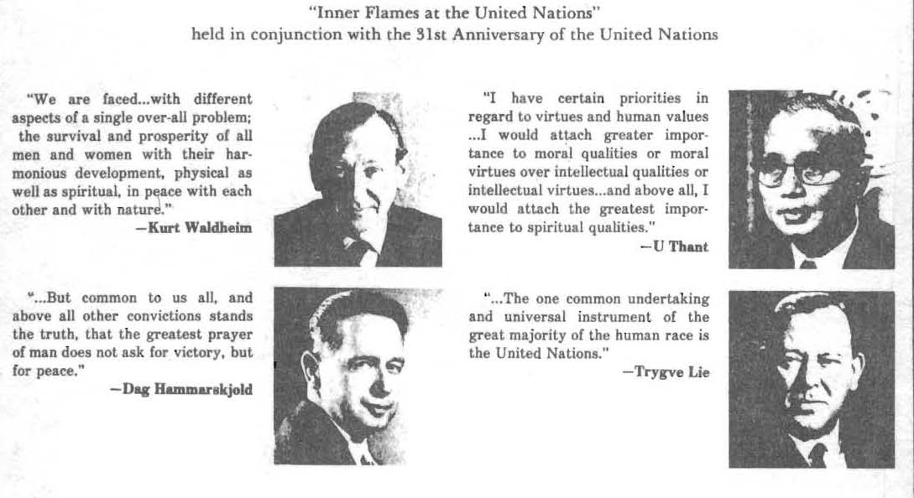
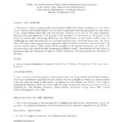
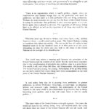 quotes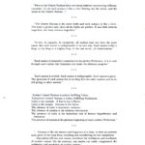
-quotes-ckg-dh-lectures-at-un-p02

